Week 3 – 4th May 2020
Dear children and parents
Here are a few of our favourite books that we like to use when we are teaching our topic about growing plants and seeds.
Some of these books you may already know and some of these books are ones that Early Years teachers have filmed for you to listen to.
We have attached YouTube Links for some - but not all - of these book titles. Please remember to make sure that you are clicking on the links when you have an adult nearby, because sometimes you get silly adverts which need to be skipped!
You may have some stories or information books about plants and growing at home, already. If you do, please would you take a photo of you holding the book and post it on your Tapestry Account? We would love to see other books that we don't know about!
Happy Reading, everyone!

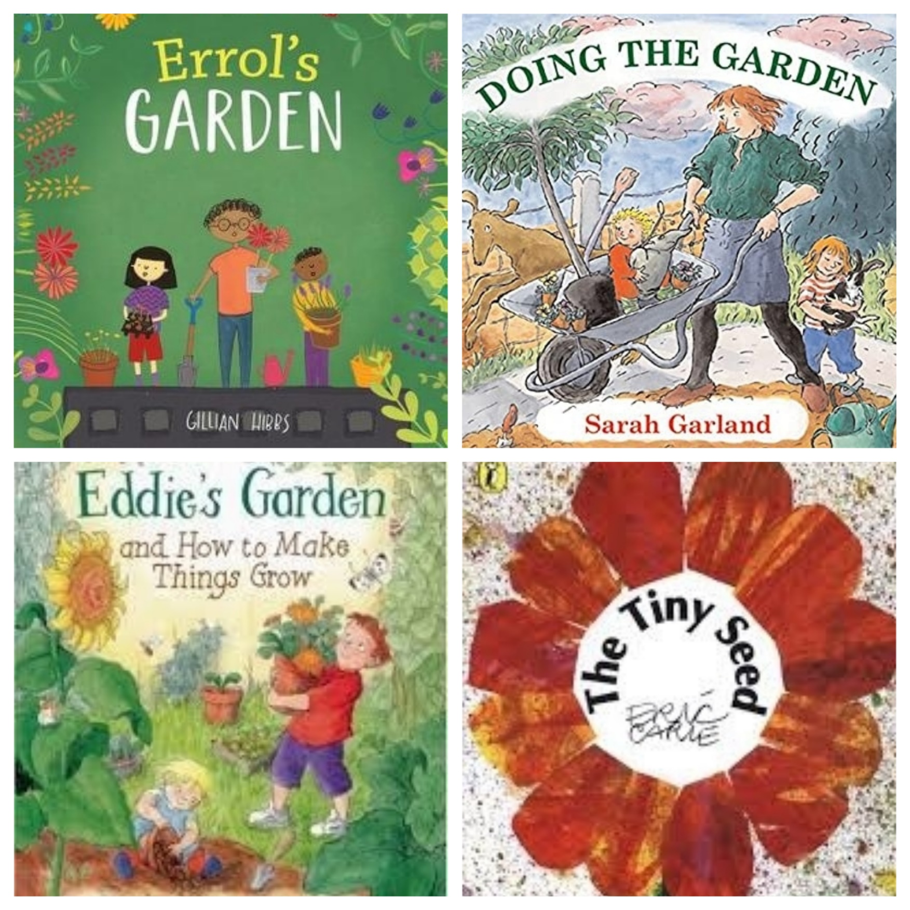
Errol’s Garden, by Gillian Hibbshttps://www.youtube.com/watch?v=rtNejXAai6c
Doing The Garden, by Sarah Garland
Eddie’s Garden and How to Make Things Grow, by Sarah Garland
The Tiny Seed, by Eric Carle
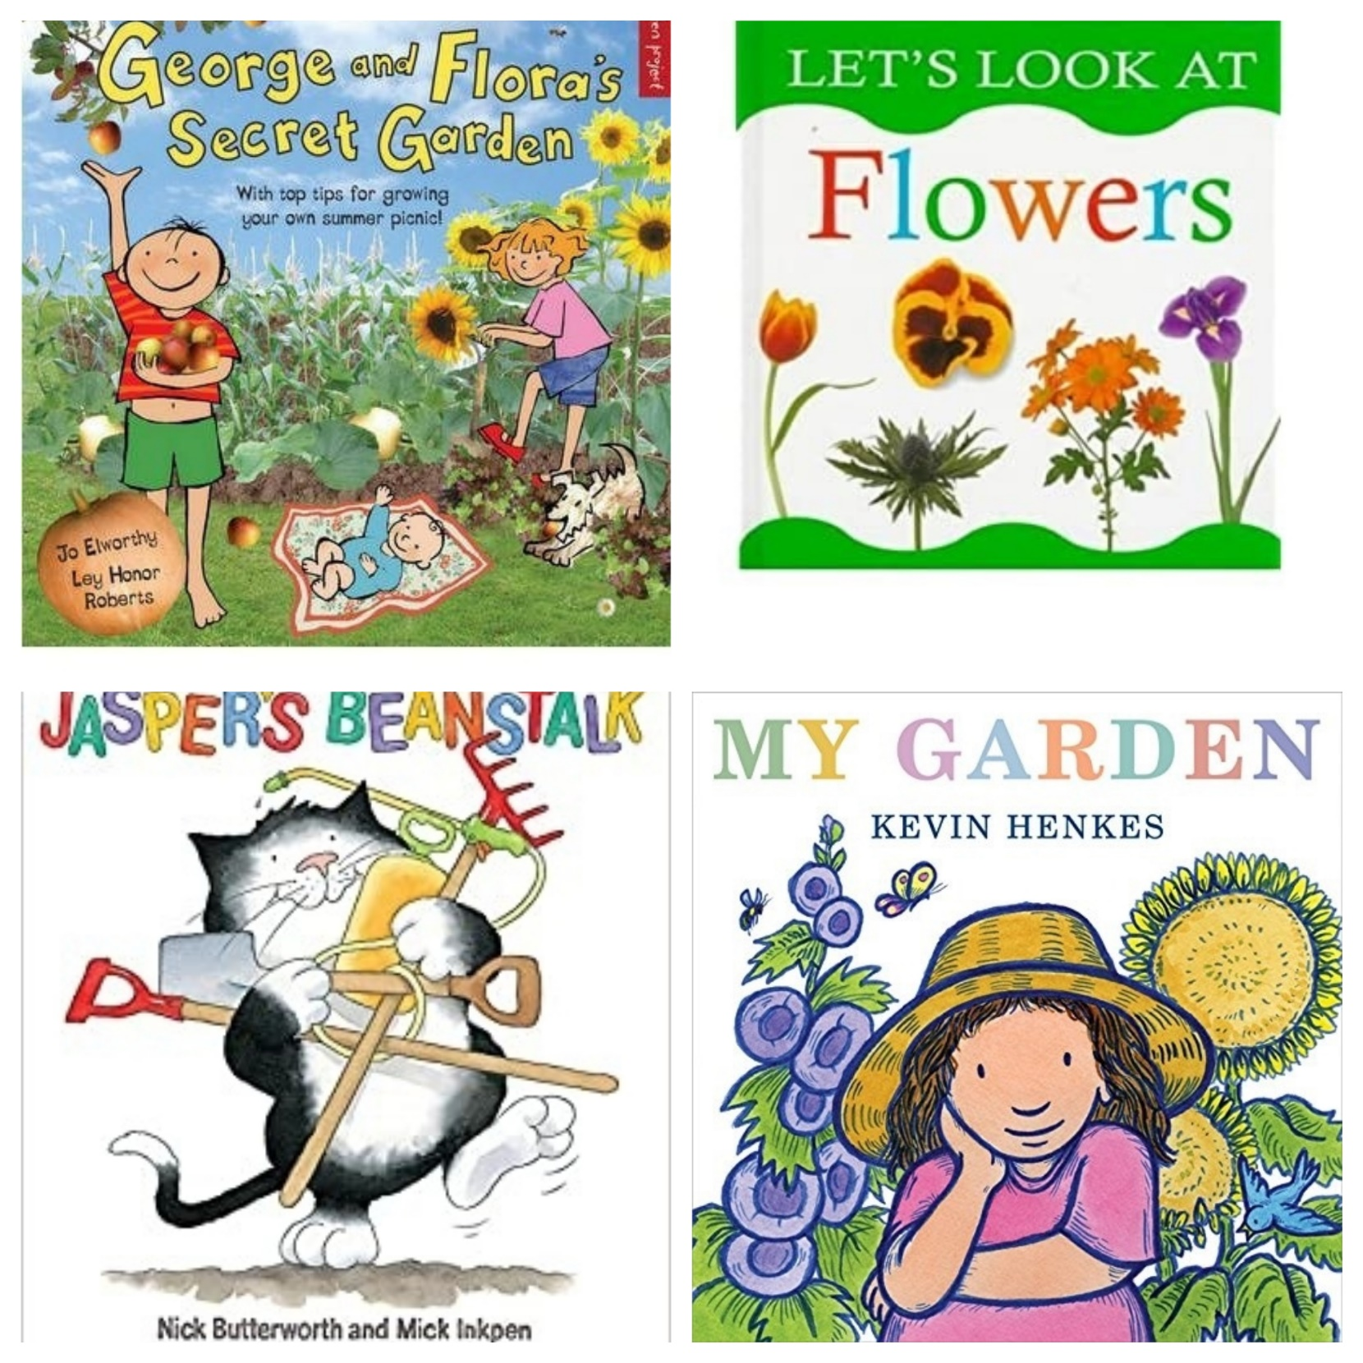
George and Flora’s Secret Garden, by Jo Elworthy and Ley Honor Roberts
Let’s Look At Flowers, by Nicola Tuxworth
Jasper’s Beanstalk, by Nick Butterworth and Mick Inkpenhttps://www.youtube.com/watch?v=Da6lxY_8jmU
My Garden, by Kevin Henkeshttps://www.youtube.com/watch?v=ebJXVJLfAe8
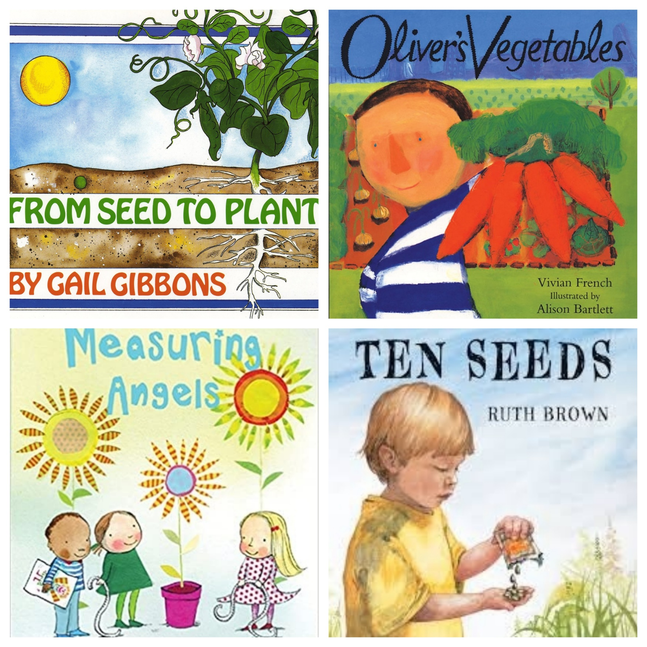
From Seed to Plant, by Gail Gibbonshttps://www.youtube.com/watch?v=Rb7n_B8kzNY
Oliver’s Vegetables, by Vivian French and Alison Bartlett
Measuring Angels, by Lesley Ely and Polly Dunbar
Ten Seeds, by Ruth Brownhttps://www.youtube.com/watch?v=Fbeo2jurFFM

