Writing an Alternative Traditional Tale
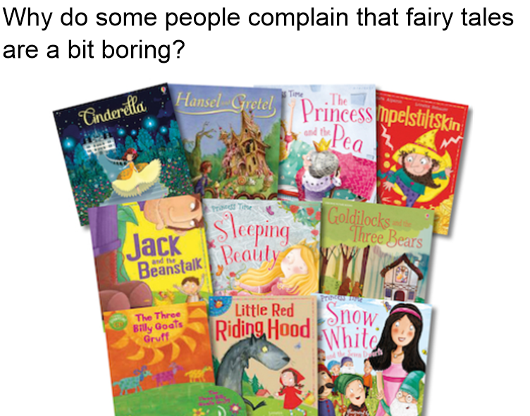

Your job this week is to create your own alternative traditional tale – a twist on those famous stories we heard when we were younger!

Lesson 1
Watch the clip of Roald Dahl’s ‘Revolting Rhymes’ in which he switches around a famous fairy tale. https://safeshare.tv/x/ss5cab894786472

Think about a fairy tale you could give a twist to. Perhaps you could change the characters? Or change the ending? Could you consider flipping the story (having a ‘Big Bad Pig’ for example?)

Once you have decided what your story will be, complete the planning grid you will find among the documents.
Lesson 2

It is now time to write your traditional tale. Use the planning grid to help you structure your story and use the success criteria to make your story exciting for the reader!

Success Criteria
MUST | I used a range of sentence openers  I have described my characters and setting using interesting adjectives.
SHOULD | I have used ambitious language to impact upon the reader.  I have used adverbs to describe actions.
COULD | I have varied my sentence structure and sentence length.  I have used a range of punctuation (semi-colon, dashes, brackets)

Make sure that you are checking the punctuation and grammar in your writing as you go along.

Lesson 3
Read through your writing you did yesterday; then go through the steps below to edit and improve your piece of work.

- Make sure EVERY full stop and capital letter you need is included.
- Underline 3 or 4 spellings you are not sure you have got right. Use a dictionary (online if you need to) to check the spelling of your word.
- Identify 3 words you think you could improve – use a thesaurus (online if needed) to find more exciting alternatives.
- Look at the sentence starters you have used. Could you add in a fronted adverbial or a preposition opener?
- Have you used a short sentence? If not, find a place to put one!

Once you have a completed story that you are happy with, send it into your teacher using Google Classroom so that they can provide you with feedback!

