WALT solve multi-step word problems
Mild
1. Kirsty, Seb and Mina made toffee apples to sell at the school fair. They made 40 toffee apples altogether.
Kirsty sold 12 apples.
Seb sold 8 toffee apples.
Mina sold 11 toffee apples.
a) How many toffee apples were left?
b) Kirsty sold her 12 toffee apples for 25p each. How much money did she collect?

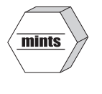
2. Holly has a box of mints.
She has 10 friends. She gives them 2 mints each. She has 6 mints left.
- How many mints were in the box at the start?

3. Tom and Nadia have 16 cards each. Tom gives Nadia 12 of his cards.
a) How many cards does Tom have now?
b) How many cards does Nadia have now?
c) Lucy also has 16 cards. She gives a quarter of her cards to Tom. How many cards does Tom have now?

4. Mr Singh buys one large box of chocolates (containing 30 chocolates) and three small boxes of chocolates (each containing 12 chocolates). How many chocolates has he bought altogether?

5. There are 600 leaflets in a box. William and Ally take 50 leaflets each.
Adam and Chen share the rest of the leaflets equally.
a) How many leaflets does Adam get?
b) How many more leaflets does Chen have than William?
6. One box contains 24 pencils. Mr Ingrey orders 12 boxes. How many pencils has he ordered altogether?

WALT solve multi-step word problems
Medium
1. Kirsty, Seb and Mina made toffee apples to sell at the school fair. They made 80 toffee apples altogether.
Kirsty sold 12 apples.
Seb sold 25 toffee apples.
Mina sold 17 toffee apples.
a) How many toffee apples were left?
b) Kirsty sold her 12 toffee apples for 50p each. How much money did she collect?

2. Holly has a box of mints.
She has 10 friends. She gives them 5 mints each. She has 13 mints left.
- How many mints were in the box at the start?

3. Tom and Nadia have 16 cards each. Tom gives Nadia 12 of his cards.
a) How many cards does Tom have now?
b) How many cards does Nadia have now?
c) Lucy also has 16 cards. She gives a quarter of her cards to Tom. How many cards does Tom have now?

4. Mr Singh buys paving slabs to go around his pond.
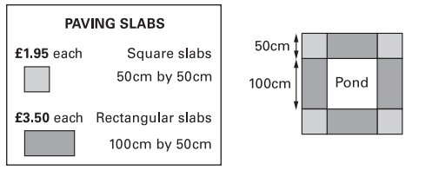
He buys 4 rectangular slabs and four square slabs.
a) What is the total cost of the slabs he buys?
b) Mr Singh says ‘It would cost more to use square slabs all the way round’. Explain why he is correct.

5. There are 2400 leaflets in a box. William and Ally take 450 leaflets each.
Adam and Chen share the rest of the leaflets equally.
a) How many leaflets does Adam get?
b) How many more leaflets does Chen have than William?
WALT solve multi-step word problems
Spicy
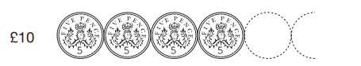
1. A 5p coin has a diameter of 1.8cm.
Holly makes a straight line of 5p coins worth £10.
How long is Holly’s line (give your answer in metres)

2. Holly has a box of mints.
She has 14 friends. She gives them 6 mints each. She has 17 mints left.
a) How many mints were in the box at the start?
b) What is the largest number of mints she could have given her 10 friends (assuming she had none herself)?

3. Tom and Nadia have 16 cards each. Tom gives Nadia three quarters of his cards.
a) How many cards does Tom have now? How many cards does Nadia have now?
b) What is the ratio of Tom’s cards to Nadia’s?
c) Lucy also has 16 cards. She gives a quarter of her cards to Tom. How many cards does Tom have now?

4. Mr Singh buys paving slabs to go around his pond.
He buys 4 rectangular slabs and four square slabs.
a) What is the total cost of the slabs he buys?
b) Mr Singh says ‘It would cost more to use square slabs all the way round’. Explain why he is correct.

5. There are 2400 leaflets in a box. William and Ally take 16% of the leaflets each.
Adam and Chen share the rest of the leaflets equally.
a) How many leaflets does Adam get?
b) How many more leaflets does Chen have than William?

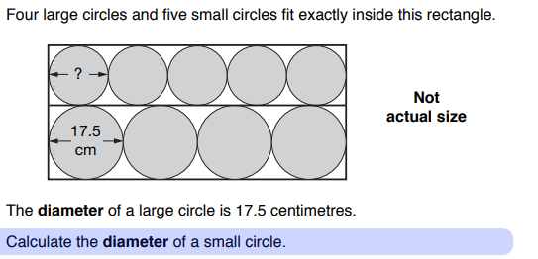
Chilli
1. Explain in sentences the steps you have to complete to solve this problem.

2. Joe has two strips of card. Each strip is 36cm long. One strip is divided into three equal parts. The other strip is divided into four equal parts.
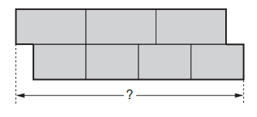
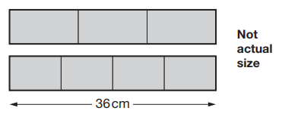
Joe uses the two strips to make this shape:

a) What is the total length of Joe’s shape?
b) Explain, in sentences, the steps taken to get to this answer.

