What would you be able to see, hear, touch, taste and smell if you were in this scene?
SMELL
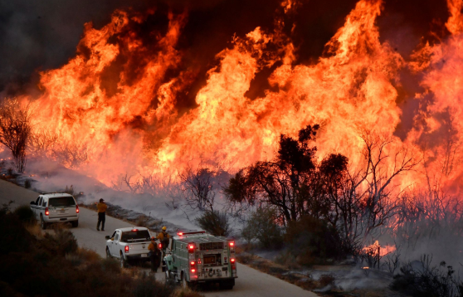
SIGHT

TASTE
TOUCH

HEAR

