Chilli Maths Activities

For each of these challenges, if you google search the title (e.g. Making a Difference) and NRICH, then you should be able to get onto the question page where you can click the ‘solutions’ tab. Only go on the website once you have had a good go at the challenge!

Day 1
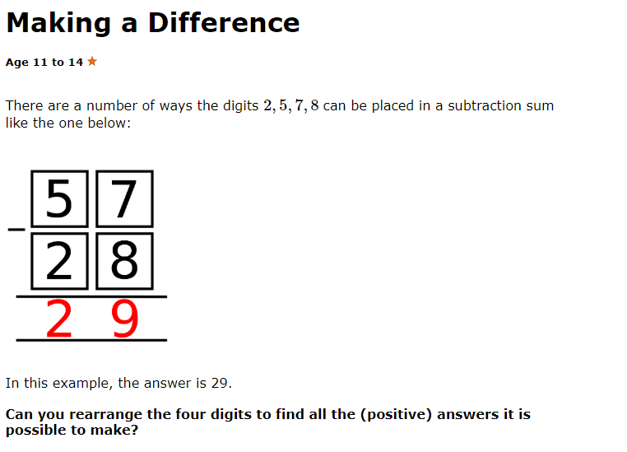
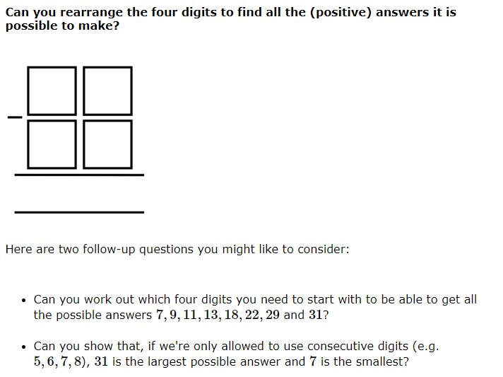

Grow up Fast
Julie and her daughters Megan and Zoey have the same birthday.

Today, Julie is 32, Megan is 4 and Zoey is 1.

How old will Julie be when her age is the sum of the ages of Megan and Zoey?

Hint: hint try writing this as an algebraic equation with n being the number of years that have passed. Then you should be able to write a number sentence with n on each side and work out what n is equal to

Day 2

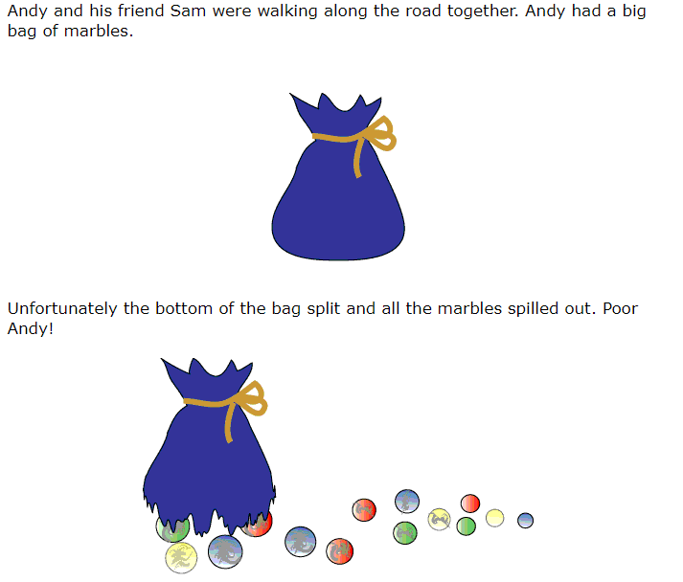
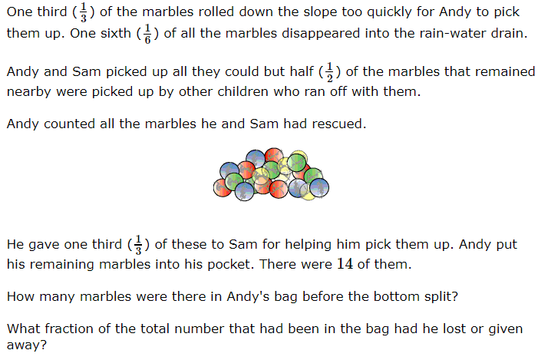

Black and Gold Storeys

A building has 50 storeys. 25 of the storeys are painted black and 25 are painted gold.

The sum of the number of gold storeys in the top half and the number of black storeys in the bottom half of the building is 28.

How many gold storeys are there in the top half of the building?

Hint: you could give an algebraic term to the number of gold storeys in the told half and another to the number of black storeys in the bottom half. Then you can write a number sentence using your algebraic terms to show that they sum to 28.

Next you could use subtraction to write a number sentence for the number of gold storeys in the bottom half. You have an algebraic term for the number of black storeys in the bottom half so you can now use your algebraic terms to write a number sentence for the storeys that make up the bottom half (25 storeys). Don’t worry if your number sentence looks odd at this point - I promise it isn’t!
Now you know how the gold storeys in the top half and the black storeys in the bottom half relate to each other, it should be straightforward to work out how many gold storeys there are in the top half of the building.

Day 3

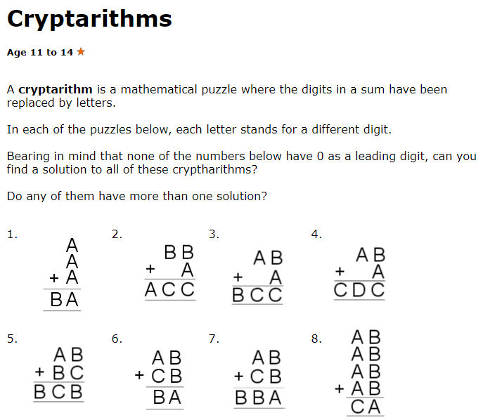

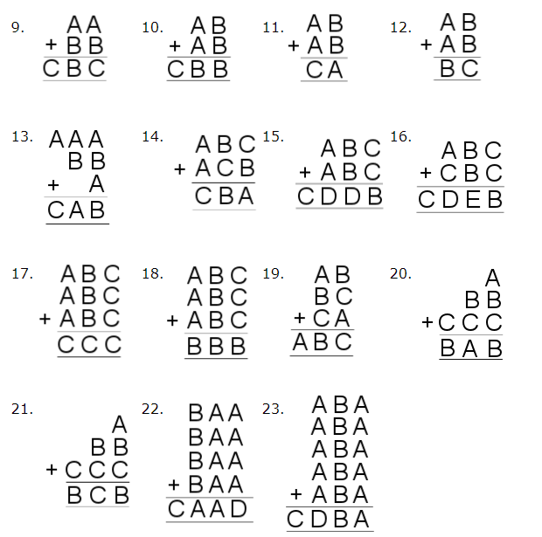
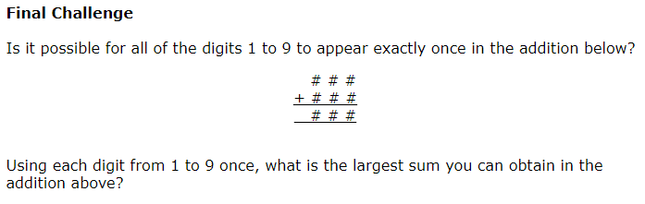

You can search the title of the problem and nrich and then go to the ‘solutions’ tab on the side when you have finished to compare your answers with other pupils’ responses.

Day 4

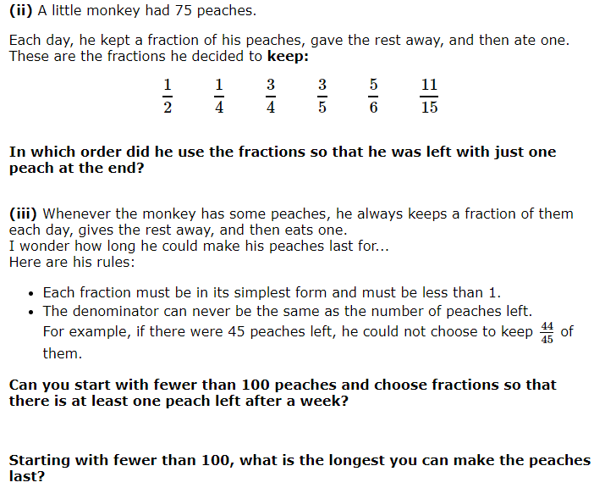
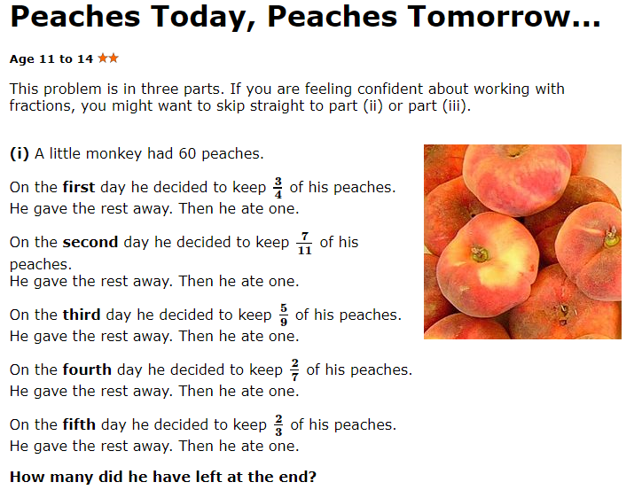
Day 5

Multiples Sudoku
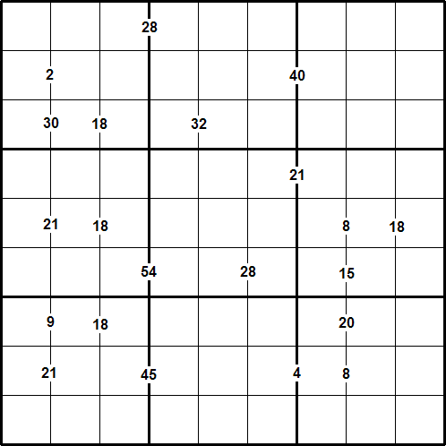
Rules of Multiples Sudoku
Like a conventional Sudoku, this Multiples Sudoku has two basic rules:
- Each column, row, and 3 x 3 subgrid must have the numbers 1 to 9.
- No column, row, or subgrid can have two cells with the same number.
The puzzle can be solved with the help of the numbers which are placed on the border lines between selected pairs of neighbouring cells.
These numbers are the product of the two digits in the cells to the left and right of the clue.
For example, where there is a 12 on the line between two neighbouring cells, the cells must contain 2 and 6, or 6 and 2, or 3 and 4, or 4 and 3.

Would You Like a Jelly Baby?
In Tom's pocket there are 8 watermelon jelly babies, 4 vanilla jelly babies and 4 butter popcorn jelly babies.

What is the smallest number of jelly babies he must take out of his pocket to be certain that he takes at least one of each flavour?

