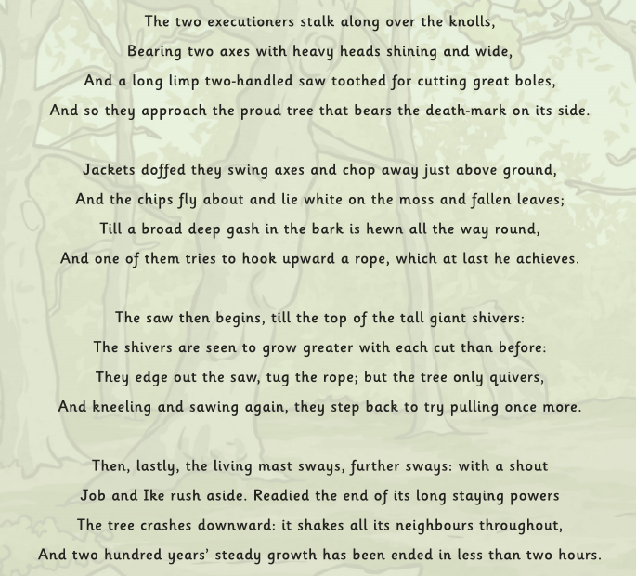
Throwing a Tree
By Thomas Hardy

Follow up task
1.
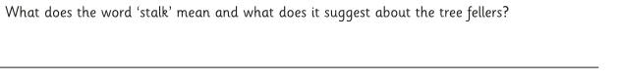
2.
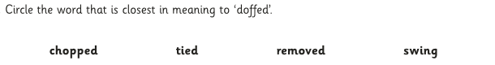
3.
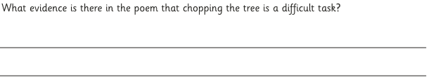
4.
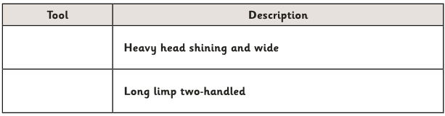
5.
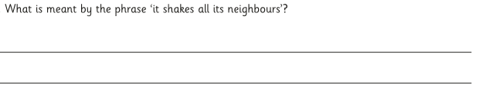
6.


