MILD
WALT solve division problems
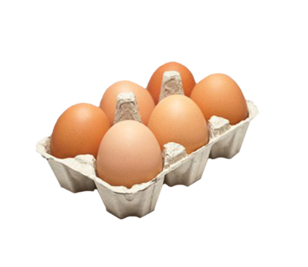
A shop has 143 eggs.
There are 6 eggs in a box.

How many full boxes of eggs can the shop have?
How many eggs would be left over?

Michael is selling tickets for a show. Tickets cost £8 each.
By the end of the day, Michael has made £96.

How many tickets did he sell?

Solve the division questions below. Leave your remainders in decimals.
3469 ÷ 5 = 4036 ÷ 4 =
3782 ÷ 10 =

Penny, Malaika and Jaden have 2478 playing cards. Jaden takes half of the playing cards. Penny and Malaika take half of what is left.
How many playing cards do they each have?
Penny - Malaika - Jaden -

6 tickets cost £75. What is the mean cost of each ticket?

Paul says, “ If I divide an even number by an odd number, I will always have a remainder”
Explain if he is correct.

MEDIUM
WALT solve division problems
A shop has 543 eggs.
There are 6 eggs in a box.

How many full boxes of eggs can the shop have?
How many eggs would be left over?
Michael is selling tickets for a show. Tickets cost £15 each.
By the end of the day, Michael has made £105.

How many tickets did he sell?

Solve the division questions below. Leave your remainders in decimals.
3469 ÷ 5 = 4036 ÷ 4 =

Solve these division questions. Leave your remainders as fractions.
3781 ÷ 2= 5752 ÷ 3 =

A school are going on a trip to the pantomime. There are 7 classes, with a mean of 25 children.
Each coach carries 50 children.
How many coaches will be needed to transport the whole school?

An adult ticket costs £12. A child ticket costs £8.
Claire buys 3 adult tickets and 2 child ticket.
What is the mean cost of each of the tickets she buys?

Paul says, “ If I divide an even number by an odd number, I will always have an odd answer”
Explain if he is correct.
SPICY
WALT solve division problems
A farm produces 29 eggs a week, that are packaged into boxes of 6.
There are 52 weeks in a year.

How many full boxes of eggs can the shop produce per year?
Michael is selling tickets for a show. Tickets cost £23 each.
By the end of the day, Michael has made £276.

How many tickets did he sell?

Solve the division questions below. Leave your remainders in decimals.
34069 ÷ 5 = 4036 ÷ 7 =

Solve these division questions. Leave your remainders as fractions.
3781 ÷ 2= 5752 ÷ 3 =

A school are going on a trip to the pantomime. There are 7 classes, with a mean of 25 children and 2 adults per class.
Each coach carries 52 people.
How many coaches will be needed to transport the whole school?

An adult ticket costs £17.30. A child ticket costs £8.05
Claire buys 3 adult tickets and 2 child ticket.
What is the mean cost of each ticket?

Paul says, “ If I divide an even number by an odd number, I will always have an odd answer”
Explain if he is correct.
Chili Challenge

3781 ÷ 4
Use this number sentence to create word problems with the following answers:
- Where you round the answer up to the next whole number
- Where you round the answer down
- Where the answer would be best given with a decimal remainder
- Where the answer would be best given with a fraction remainder.

Chili Challenge

3781 ÷ 4
Use this number sentence to create word problems with the following answers:
- Where you round the answer up to the next whole number
- Where you round the answer down
- Where the answer would be best given with a decimal remainder
- Where the answer would be best given with a fraction remainder.

Chili Challenge

3781 ÷ 4
Use this number sentence to create word problems with the following answers:
- Where you round the answer up to the next whole number
- Where you round the answer down
- Where the answer would be best given with a decimal remainder
- Where the answer would be best given with a fraction remainder.

