Writing activities for week beginning 20th April
The first three writing lessons this week will be linked. On Monday, you will plan your letter; on Tuesday, you will write your letter; and on Wednesday you will edit and self-assess your letter (and maybe get it ready to send to someone!).
At the moment, we are making history. With schools and countries in lock down all over the world, this is a time in our lives that people are going to look back on. Coronavirus is not just something that is happening in our country, it is happening all over the world.
Think back to the beginning of the year where you imaged that you were an evacuee during World War II. In those lessons, you thought carefully about what information your parents would want to hear and the things that made that period of time different to how it is today. We (the Year 6 teachers) would like you to take the opportunity now to think about two key points:
- Who is someone you would like to write a letter to?
- What do you think that person will want to hear in your letter about you being in lock down?
Activity 1 (Monday):
Read through the model text for an emotive letter.
Dear Mum and Dad,
I have arrived safely at the farm which is like a different planet to back at home! The journey here was reasonable but quite scary: there were hundreds of us, all labelled up, on the train which seemed to travel across miles and miles of green! Then, when we arrived at the quiet, old station, we all had to stand smartly in a line and wait to be chosen. I don’t mind admitting I was very nervous! In the end, we were selected by a Mr and Mrs Jones who took us back to their farm where we met their sons (Clarence and Wilfred) – they seem friendly but I am still quite wary.
The farm itself is huge – every day, we have had to go out and help with jobs: collect the produce, plough the fields and sweeping up any loose hay. I know it sounds peaceful but some terrifying monsters live here: one is a huge pink beast with a button nose and curly tail; another is a towering creature with large teeth (some people even ride this one!); finally, there is what looks like a walking ball of wool with a black nose and large pink ears. The family say there is nothing to be scared of but I’m not so sure! However, you would love how the tweeting birds greet you with their morning welcome!
I miss you a lot and so wish you were here with me. I heard that there was another bombing raid on the city – please write back to reassure me that you were not hurt. Also, how is Bingo? I miss seeing him chase his little ball around the living room! Would you be able to send me some toffee – the family here prefer to eat things I think they call ‘banamas’?!
With all my love and affection,
Lily.

Look at these pictures and think about what you would like to include in your letter:

- What is happening in the world at the moment?
- Why are schools closed and parents working from home?
- Why can’t we just go and visit our friends or play with them?
- How are we still communicating without being able to see each other face-to-face?
- What are we doing to stay safe?
Once you have thought about these images and the bullet points, complete the plan on the next page!

Name of person staying at home: ________________________
How do you feel about the situation? ___________________________________________
Your Ideas
Describe this moment in History
Why are you at home? What has happened up until this moment?

Describe where you are
What is it like inside?
What is it like outside?
What you are enjoying about it.
What you are disliking.

What you want the person you are writing to do/send.

Activity 2 (Tuesday):
Today, you are going to write your letter to someone you care about. Your letter needs to be three-four paragraphs long. You could either type or hand-write. Think about these targets while you are writing:
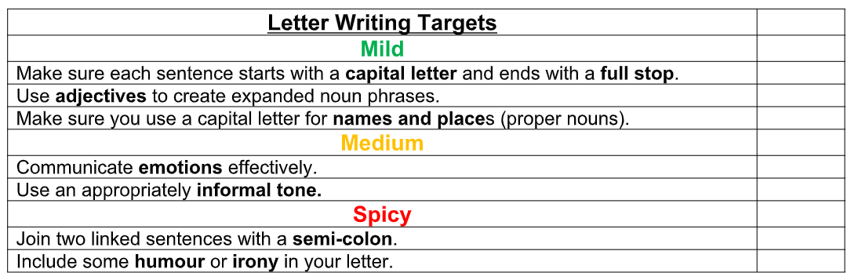
Remember: Think carefully about what the person you are writing to will want to hear!

Activity 3 (Wednesday):
Today, you are going to edit and then self-assess your letter.
First, read your writing out loud from start to finish, and make and spelling, grammar or punctuation changes necessary. Tally how many changes you have made here:
Next, fill in the self-assessment grid below and write down how you have meet each of the targets. If you cannot find one of the targets in your writing, go back to your story and add in an example.

Success Criteria | Self-Assessment
Use the structure of a diary entry

Include adjectives to show feelings

Use a rhetorical question

Use a range of conjunctions

Explain how this moment in time is different to your usual routine

Use capital letters for proper nouns

If you have made lots of changes, you may want to write or type it out again!

