Co-ordinating and Subordinating Conjunctions
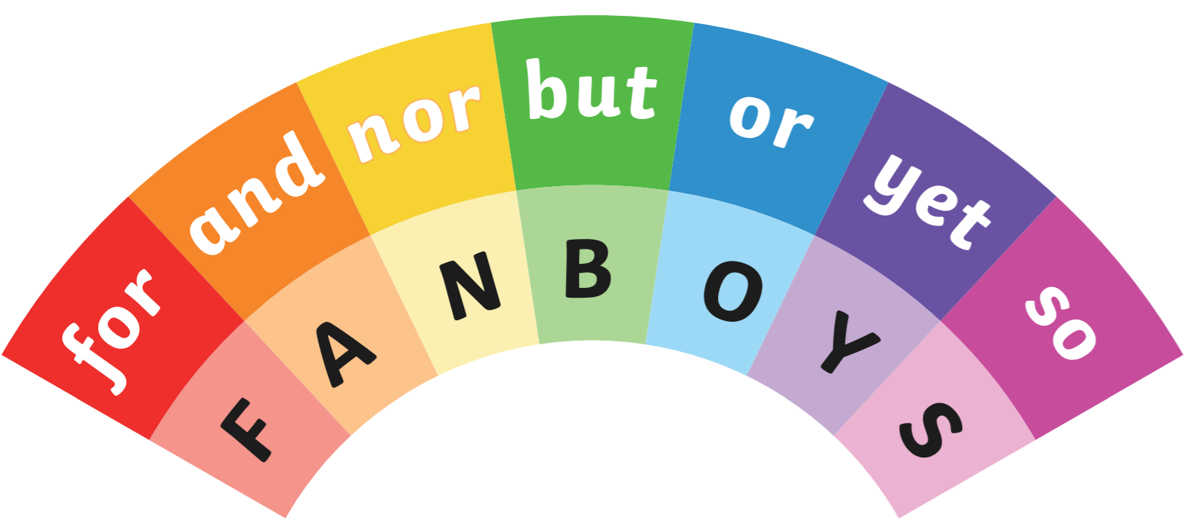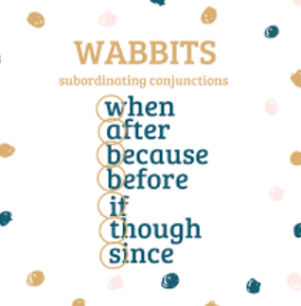
Mild
Choose coordinating conjunctions (FANBOYS) to complete these sentences.
1. I went to bed very late I am tired today.
2. I listened to the weather forecast put an umbrella in my bag.
3. I enjoy placing hockey it’s not my favourite sport.
4 .We could go to the park to the cinema.

Choose subordinating conjunctions (WABBITS+) to complete these sentences.
1. My brother is grumpy he missed Joe Wick’s workout.
2. I will always support my local team, they always lose!
3. We have to tidy up we are allowed to eat our lunch.

Choose a pair of conjunction from the box to complete these sentences.
1. I’m not sure I’m going to the match not.
2. My mum is a brilliant doctor, she is a great runner too.
3. The weather is forecast to be hot humid.

Name the type of conjunction used in each sentence (it will be either coordinating or subordinating)
1. She said she was going to come although I don’t think she was that keen.

2. He was chosen to represent the school because he was the most talented swimmer

3. He always seemed so confident yet he was actually quite shy.

Now have a go at writing your own sentences using a range of conjunctions.
For example:
I would like to see my friends but Boris Johnson has told everyone to stay at home.
_______________________________________________________________________________________________________________________________________________________________________________________________________________________________________________________________________________________________

Spicy
Use a coordinating conjunction to rewrite these pairs of sentences as one sentence. Make sure that your sentences are accurately punctuated.
1. We enjoy watching films. We enjoy going bowling.
2. He wants to win the race. He is running more slowly than the others.
3. My sister loves cake. I am going to bake a cake for her birthday.

Use a subordinating conjunction to rewrite these pairs of sentences as one sentence.
1. My hands are freezing cold. I forgot to bring my gloves today.
2. My mum takes me to the match every week. She doesn’t like football.
3. I take the dog for a walk every day. Sometimes it is raining.

Use a pair of conjunctions from the box to rewrite these pairs of sentences as one sentence.

For example: ‘My mum is a brilliant doctor. She is a great runner too.’ would become ‘My mum is not only a brilliant doctor, but she is a great runner too.’
1. I like carrots. I like asparagus.
2. I don’t know if it’s going to be sunny. I don’t know if it’s going to be raining.
3. She is the regional champion. She is also the national champion.
Now have a go at writing your own sentences using a range of conjunctions.
For example:
I would like to see my friends but Boris Johnson has told everyone to stay at home.
______________________________________________________________________________________________________________________________________________________________________________________________________________________________________________________

