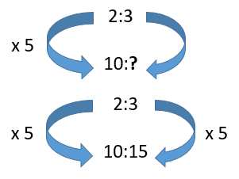
Mild
Remember to set it up.
For example, for every 2 apples Miss Chilcott buys, Miss Dilnot buys 3. Ratio = 2:3
If Miss Chilcott buys 10 apples, how many does Miss Dilnot buy? 10: ?

1. Michelle earns £1 for every £2 that David earns.
a) How much would David earn if Michelle earned £10?
b) How much would Michelle earn if David earned £40?
2. Here is a triangle
5cm
5cm

4cm

Cleo increased the size of the triangle by a scale factor of 3. What is the perimeter of the triangle that Cleo draws?
3. Hamir makes a 1:24 scale model of a real plane. The model has a length of 5 cm.
What is the length of the real plane?
4. Charlie and Paul have 16 grapes. They shared a bunch of grapes in the ratio 5:3.
How many grapes does Charlie have?
5. Rectangle B is an enlargement of Rectangle A. What is the length of side x?
400 cm
B
A
120 cm
240 cm
x

6. Here are two similar shapes. Write the ratio of side a to side b.

b
9 cm
a
3 cm

7. Squash should be made in the ratio 1:3 for squash to water. If you have 2 litres of water, how much squash do you need?

Medium
1. Michelle earns £5 for every £2 that David earns.
a) How much would David earn if Michelle earned £20?
b) How much would Michelle earn if David earned £6?
2. Here is a triangle
5cm
5cm

4cm

Cleo increased the size of the triangle by a scale factor of 4. What is the perimeter of the triangle that Cleo draws?
3. Hamir makes a 1:24 scale model of a real plane. The model has a length of 30cm.
What is the length of the real plane?
4. Charlie and Paul share a bunch of grapes in the ratio 5:3
If Charlie gets 20 grapes, how many grapes were in the bunch?
5. Rachel gets £8.00 pocket money each week. Gareth’s pocket money is 80% of this amount. Dawn’s pocket money is 90% of the amount that Gareth gets.
Rachel’s pocket money | £8
Gareth’s pocket money
Dawn’s pocket money

6. Rectangle B is an enlargement of Rectangle A. What is the length of side x?
240 cm
B
A
120 cm
180 cm
x

7. 1 litre of red paint is needed to paint all the faces of a cube of side length 3m. How many litres of paint would it take to paint all the faces of a cube of side length 6m?
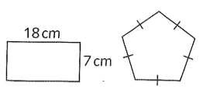
8. The perimeter of the regular pentagon is 20% larger than the perimeter of the rectangle.

a) What is the perimeter of the pentagon?
b) What is the length of one side of the pentagon?

Spicy
1. Charlie and Paul share a bunch of grapes in the ratio 5:3. If Paul gets 21 grapes, how many more does Charlie get?
2. Marion is 6 years older than Jada. The total of their ages is 90 years. Put this information into an algebraic expression. How old is Jada?
3. An orange drink is one part orange squash and seven parts water. How much orange squash is needed to make 12 litres of orange drink?
4. The width of a rectangle is three times shorter than its length. The rectangle has a width of 6cm.
a) What is the length of the rectangle?
b) What is the perimeter of the rectangle?
5. 1 litre of red paint is needed to paint all the faces of a cube of side length 3m. How many litres of paint would it take to paint all the faces of a cube of side length 6m?
6. a) Fill in the missing length of the side.
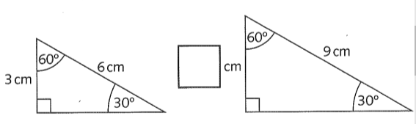
b) Explain in words how you found the answer.
7. The perimeter of the regular pentagon is 20% larger than the perimeter of the rectangle.

a) What is the perimeter of the pentagon?
b) What is the length of one side of the pentagon?
8. On a map, 1cm represents 23km.
The distance between two towns is 775km.
On the map, what is the measurement in cm between the two towns? Round your answer to the nearest tenth of a cm.

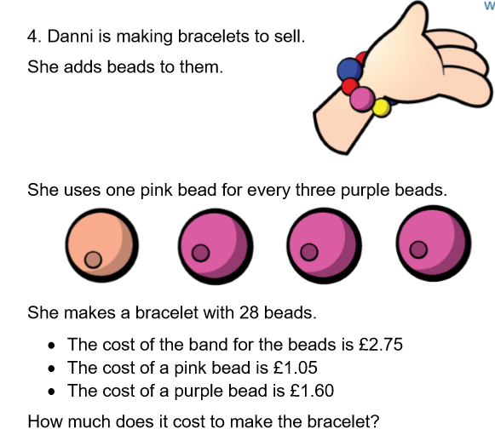
Chilli


