Writing activities for week beginning 30th March
This week, your three writing activities will be linked. On Monday, you will plan your warning story; on Tuesday, you will write your warning story; and on Wednesday you will edit and self-assess your warning story.
Activity 1 (Monday):
Read through the model text for the warning story.
The Canal
“Now, I do not want you two playing down by the old canal. You know it’s playing with fire,” said Mrs Mac, digging her hands deep into the washing up bowl. Tom and James nodded as if they understood.
Ten minutes later, they reached the old canal. Cautiously, they peered in. The water was still, black and deep. By the banks, they could see a rusted shopping trolley, old crisp packets and soggy newspapers. In the reeds, something rustled.
Although it looked dangerous, Tom grinned at his friend. He took the rope swing that dangled from an overhanging branch and leaped out over the canal. Swinging backwards and forwards, he whooped like a siren. Even though James was laughing, inside his heart was thudding. It was his turn next.
“You scared?” asked Tom, staring at him. James did not want his friend to think that he was a coward so he ran back, leapt out and sailed across the canal. But halfway over, the rope snapped. James crashed down into the water. Tom gasped. James was no swimmer!
Desperate, Tom leapt in. At first, he could see nothing - just darkness and weed tangling his feet. Then he saw red! It was James’s hoodie. Frantically, Tom grabbed it and tugged James to the side. James lay on the bank, gasping and wheezing like an old man.
Twenty minutes later, they were standing in Mrs Mac’s kitchen. They had to explain what had happened and Mrs Mac grounded them for a week! After all, she had warned them often enough. The canal was dangerous. They had been lucky. This time.


Look at these pictures and think about the warning story that you are going to plan. You need to decide:






- Where the main characters are going to go
- What is going to go wrong while they are there
- How one character is going to save the other one
Once you can answer these three bullet points, move onto the next page to complete the plan.

Structure of the Story | MY PLAN
Paragraph 1
- Warning given
- Warner and 2 main characters (MCs) introduced

Paragraph 2
- MCs go to place they were warned about
- Describe setting

Paragraph 3
- MC does something dangerous
- Other character responds
Paragraph 4
- Something goes wrong to one MC
- Something even worse is revealed

Paragraph 5
- Other MC tries to rescue
- Other MC successfully rescues

Paragraph 6
- Back where they started
- Consequence

Activity 2 (Tuesday):
Today, you are going to write your warning story. Your story needs to be six paragraphs long with at least two sentences in each paragraph. You could either type or hand-write. Think about these targets while you are writing:
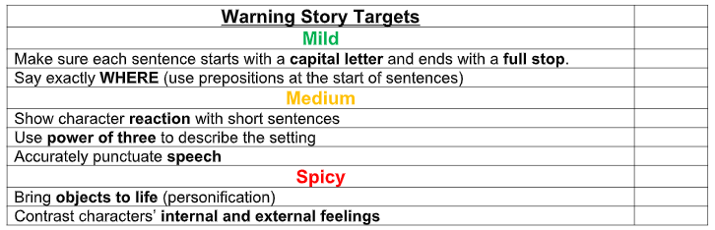

Activity 3 (Wednesday):
Today, you are going to edit and then self-assess your warning story.
First, read your writing out loud from start to finish, and make and spelling, grammar or punctuation changes necessary. Tally how many changes you have made here:
Next, fill in the self-assessment grid below with an example of each of the targets. If you cannot find one of the targets in your writing, go back to your story and add in an example.
Target | Example from my writing
Say exactly where (use prepositions at the start of sentences)
Show character reaction with short sentences
Use power of three to describe the setting (e.g. the water was cold, dark and deep)
Accurately punctuate speech

