Lesson 1
You can chose the name of your own project but I’m going to call this one Mayan game of doom!
First I want to add a person sprite so I will go to New Sprite, click on the button for ‘choose sprite from library’, choose people, and I would like to be Sam.
We can now delete the cat sprite by doing a right click then choosing delete.
Now we need a maze for Sam to try to get out of so I will go to ‘upload sprite from file’ and choose Maze 1. If you have uploaded this as a background you need to delete it and re-upload it as a sprite. I have saved it on the website so you can right click and ‘save image as’ to save it into your downloads and then upload it to scratch from there. It is called Maze 1.
Now you need to code the Maze Sprite. When the green flag is clicked, we want to show the maze and we want it in the middle so x and y should both be 0.
We want Sam to be able to move around the maze so now we need to code Sam.
When the green flag is clicked,
if loop (from control)
right arrow pressed (from sensing)
then go to motion, point in direction 90 (which is right) and, also from motion, choose move 10 steps, but change the 10 to a five.
Repeat for going right, up and down. Right click to duplicate.
We always want this to happen so I’m going to put a forever loop around these commands.
Let’s try it out. To start, press the green flag.
He’s too big so we need to press the shrink button and then click on Sam as many times as we need to. He needs to be so small that he isn’t touching the walls of the maze, or he will be stuck. This is really really small – you will think it looks silly but I promise he has to be that small to be able to not be touching the walls of the mazw.

We always want to start in the same place in the maze so let’s add when green flag clicked, go to x y (within motion) and automatically the x and y are set to the current position of the sprite.
At the moment, Sam can walk through the walls of the maze so we need to change the coding so he can’t. For this, we need to tell him to walk backwards whenever he tries to walk through a wall.
Get an if loop and put it under move five steps.
Add if touching (from sensing) and choose maze 1.
Then add move 10 steps (from motion) but we need to go back the same number of steps he was trying to go forward through the maze wall so that would be -5.
Put in the same if loop for left, up and down.
Now Sam should be able to move around the maze.
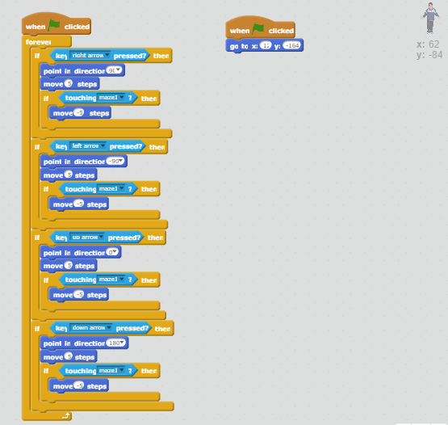
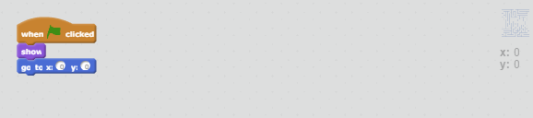
You could think about these questions before moving on to the next lesson:
- What happens if you move the forever loop and why?
- What happens if you delete the code ‘When green flag clicked, go to x and y’?
- What happens if you change the number of steps moved within the if loops?
- Can you find a different way to move the sprite by changing x and y rather than changing the way the sprite is facing and moving in that direction?

Lesson 2
Now that we have our character walking around our maze, we want to add in a way of earning points and keeping score. In the rainforest, you need food and water to survive so we need to add a sprite of a glass of water and a sprite of a banana.
We need to resize them using the shrink button and place them somewhere in the maze.
To make something that keeps score, we need to go to the orange data tab, choose make a variable, and then type in score.
On the glass of water tab, click when green flag, show, set score to 0 (because we want to start with no points) then in a forever loop, insert an if loop, and if touching (which is a sensing command) Sprite 1 (Sam) then hide and change score by 1.
You can copy that code over for the banana by putting it into the backpack and then dragging it up for the banana sprite.
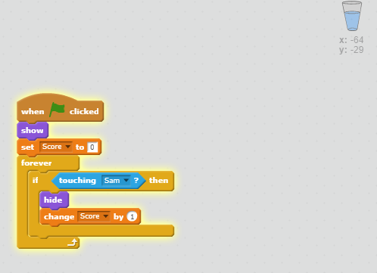
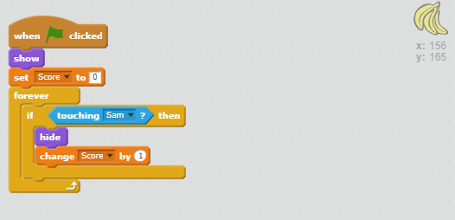
Try thinking about the following questions:
- Can you award different numbers of points for the different things that you could pick up? How would you do that?
- Could your food and water pop up in different places at different times during the game? How would you do that?

Lesson 3
To add challenge to the game, our main character will be being chased by an animal who will eat him if he catches up. First we need to add our new sprite- the chaser. I’m going to make mine a monkey.
The monkey can see Sam so it is going to follow him and it can swing through the trees so it doesn’t have to follow the maze walls like Sam does.
Choose where you want the monkey to start (not too close to Sam or you don’t have a hope) and add the code when green flag clicked, go to x and y.
Now we want to make the monkey move towards Sam. When the green flag is clicked, show, then in a forever loop, point towards sprite 1 (Sam), move 10 steps, wait 1 sec.
So if we try this out...he will move towards Sam and possibly eventually crash into him.
If the monkey gets Sam, we need to end the game so I am going to create a new sprite which is like the text box which pops up when the game is over. Click the paintbrush next to new sprite which means you’re going to make your own. Chose the rectangle icon to draw the shape, then chose the colour. Use the T to add a text box and type in a message - I’m going to type Game Over in yellow and drag it to the middle.
That was all done in the costume for this sprite and now I need to go to scripts for this sprite to code it.
I don’t want this to show at the beginning of the game so when green flag clicked, hide.
We want the monkey to send a message to the text box to pop up if it (the monkey) bumps into Sam. On the monkey sprite, under wait 1 second, add an if loop and put in if touching Sprite 1 (that’s Sam) broadcast (from events) and choose 'new message’ at the bottom. Type in the new message as ‘Game Over’ - this isn’t actually what will pop up, this is just the name of the message that is being broadcast/sent.
Now we need to code the Game over text box to pop up when the ‘game over’ message has been broadcast. So when green flag clicked we want it to hide (so it’s not showing from the beginning of the game). Then When I receive Game over (an event), show, then stop all (a control).
Let’s try that out.
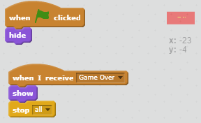
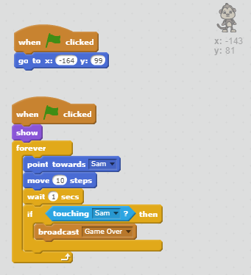
- What happens if you remove, ‘wait one second’ from the monkey sprite? Is it still possible to win the game?
- Could you make the monkey pop up at different places for each game? Try using the ‘random control’.
- Instead of the monkey touching Sam leading to game over, is it possible to loose lives rather than go straight to game over? You could create a variable for lives, start with 3 and subtract 1 every time the monkey touches Sam.

Lesson 4
We need a celebratory message for Sam if he manages to get out of the rainforest alive and with enough food and water to survive. So let’s add another sprite which we can make ourselves which says Congratulations, you have managed to escape the rainforest alive.
We need something to be at the end of the maze which Sam can bump into to trigger the congratulatory message. Let’s have a red cross to show the end point. We need to make this sprite. Then resize it and put it in position. Now we can code the cross so that when Sam bumps into it, it broadcasts a message to make the congratulations text box appear.
We want the red cross to be visible for the whole game so when green flag clicked, show then in a forever loop, and an if loop, so if touching sprite 1 (Sam) then broadcast, and make a new broadcast - Congratulations.
Then on the Congratulations sprite, we need to code it so that it appears when the message is broadcast. We don’t want it showing at the beginning of the game so when green flag clicked, hide.
Then when I receive, and choose congratulations, show, then stop all.
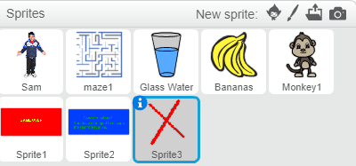
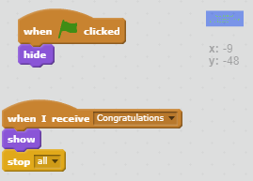
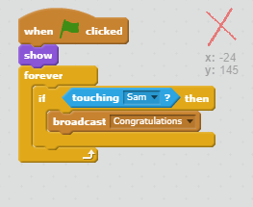

Once you have added this code and checked that you game works (and that it is possible to win), change your code to make your game either easier or more difficult to win.
Think about:
How quickly Sam moves
How quickly your chaser moves
How easy it is to get points (are the point scoring sprites moving)?

Extension for confident scratchers!
You could try adding another maze to have a multiple level game. You will need to have something which broadcasts to move on to the next maze.

