What we are learning about:

Our topic/theme this half term is:

Magic in the Making

The key text we will be using will be:

Harry Potter and the Philosopher’s Stone

We will be learning to:

With this term’s topic centred around JK Rowling’s Harry Potter series; children will be transported into a magical world through potion making, creating the scenes of Hogwarts through art and literature, and reading a range of fiction and non-fiction magical texts. The themes covered this half term will include showing tolerance, respecting difference and the importance of teamwork.

Mathematics:

In Mathematics, our focus will be children’s understanding, explaining and reasoning with place value. We will also consolidate and extend skills in addition, subtraction, multiplication and division.

We will develop a mastery of mathematical language to help children explain their understanding of concepts in more detail.

What we are learning about

English
Reading:

Our key text is ‘Harry Potter and the Philosopher’s Stone’ which we will be reading together as a whole class. In our reading, we are learning to identify and discuss themes, as well as, recall and retrieve facts. We will be able to make comparisons within and across different texts. Making inferences (e.g. feelings, thoughts, and motives) is another focus for this half-term. We will also look at JK Rowling’s writing style and how she creates particular characters.

Writing:

This half term we will be using the ‘Harry Potter’ novels as inspiration for a range of writing tasks. As in reading, we will have a look at JK Rowling’s writing style as a model to assist us with our own writing.

We will use a range of stimuli e.g. drama, film and written texts to support our writing of informal letters and suspense stories.

Key Vocabulary:

Noun, proper nouns, pronoun, clause, relative clause.

Solution, solute, solvent, dissolve, evaporation, filtration, reversible, irreversible.

Place value, greater than, less than, ten thousands, hundred thousands, millions, order, ascending, descending, rounding.

Homework:

In Year 5, children are expected to:
- Read at home for at least 15 minutes, 5 days a week and record 5 comments a week in their Reading Record books. Children should read out loud or discuss their book with an adult at home, for 2 of those days.
- Learn 10 spellings a week.
- Practise their times tables.
- Over the half term choose from the menu of activities below (a minimum score of 10 points is expected per half-term)

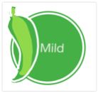  1 mild activity = 2 points | 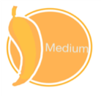  1 medium activity = 3 points |   1 Hot activity = 5 points
Use a map to find out where the people in your family were born. | Listen to a piece of orchestral music. Can you identify 3 instruments? | Make an instrument using materials that you have found around the house.
Create and sketch a mythical creature. Write a dictionary definition for your creature. | Write a welcome letter to a new person who has joined our class. Explain the rules and expectations at our school. | Create a brochure to tell prospective students all about Hogwarts school.
Find 3 things in your home that dissolve in water. | Write a list of top 5 tips to keep safe when using the internet. | Draw an imagined map of Hogwarts school and its grounds.  Fawcett Primary School:  Challenge, Opportunity, Respect, Excellence

Homework projects should be submitted via photo/video on Google Classroom by October half term.
Autumn 1, 2020



Year 5 Newsletter

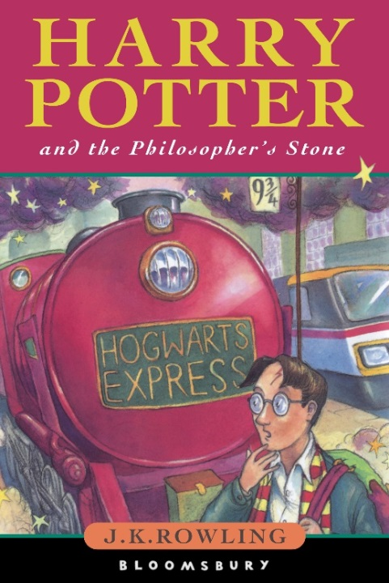
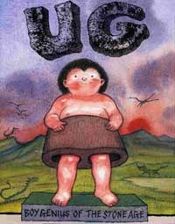
Trumpington Meadows

