What we are learning about:

Our topic/theme this half term is:

Vile Victorians

The key texts we will be using will be:

Continue to read Street Child by Berlie Doherty

We will be learning to:
We are continuing to look at life in Victorian Britain for our topic this half-term. In History, we will be studying the Victorian classroom, public health and the development of the railways. We will complete the topic with a Victorian Day where the children will experience what a Victorian classroom was like and will be expected to entertain their teacher’s in the afternoon! In Science, we will be studying forces and friction and move on to looking at life processes and living things. In Music, we will be busy rehearsing our songs for our end of term production, ‘The Lion King’.

Mathematics:
In Mathematics, we will look at measurement, including metric and imperial and converting between different units of measure. We will then review and revise the areas we have already studied in previous terms.

Throughout Maths, we will continue to apply our skills in order to solve a range of problems. We will review and consolidate formal written methods.

What we are learning about

English

Reading:
Our reading will tie in with our history topic and will once again focus on historical fiction and information texts. We will be paying particular attention to inference and deduction to explore the feelings and motives of characters in fiction texts. We will use historical sources to form and express our own opinions.

Writing:
In Writing, we will be producing our own pieces of historical writing, based on a text called ‘The Pain of the Mines’ and we will continue the theme and explore what life was like for Victorian children.

We will also be reading and writing different kinds of poetry at the end of the half-term.

Key Vocabulary:
Grammar – subordinating and co-ordinating clauses, conjunctions, parenthesis, hyphens, brackets, commas.

Mathematics – measurement, unit of measurement
Metric: millimetre, centimetre, metre, kilometre, gram, kilogram, millilitre, litre,
Imperial units: inch, foot, yard, mile, pint, galleon

Science –forces, gravity, resistance, friction, energy, life processes, life-cycle, metamorphosis

Homework:

In Year 5, children are expected to:
- Read at home for at least 15 minutes, 5 days a week and fill in their reading record each time they read. Children should read out loud, to an adult at home, for 2 of those days.
- Learn 5 spellings a week.
- Practise their times tables on Times Table Rock Stars.
- Discuss the “Talk topic” of the week.
- Over the half term, choose from the menu of activities below (a minimum score of 10 points is expected per half-term).

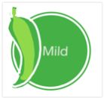  Mild = 2 |   Medium =3 |   Hot = 5
Find out the names of three famous Victorians and write a paragraph about what each person was famous for. | Find out about the life-cycle of an animal of your choice. Draw an annotated diagram of their life-cycle. | Find out about a famous Victorian – produce a poster or fact file about them.  You could include: name, important dates, why they were famous etc.
Can you find an item of food in your cupboards that weighs:  - 100g  - 500g  - 1kg  Write a list of those items. | Find a recipe where the ingredients are measured in grams. Imagine you wanted to make twice as much. Change the weight of the ingredients.  . | Follow a recipe – make sure you estimate and weigh the ingredients carefully! Bring a copy of the recipe into school. You can also take a photo of the dish, or draw a picture.
Find and read a famous children’s poem. Can you learn a verse of it off by heart? | Victorian children would have been expected to learn Copper Plate handwriting. Find out what it is. Write out the alphabet in upper and lower case Copper Plate handwriting. | COMPULSORY!  At the end of the term, we will have a Victorian Day. In the afternoon, we will have music hall style of entertainment where everyone will be expected to perform (a song, dance, joke, magic, poem etc.) You can perform on your own, or in a group.
Please bring in your ten points of homework to school on Monday 15th July.


Year 5 Newsletter

Fawcett Primary School

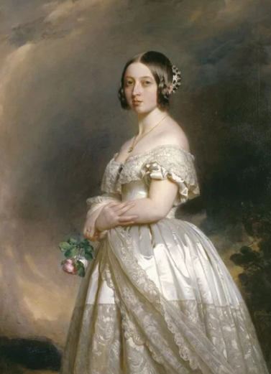
Summer 2, 2019
Trumpington Federation:
Challenge, Opportunity, Respect, Excellence

