Mountain images

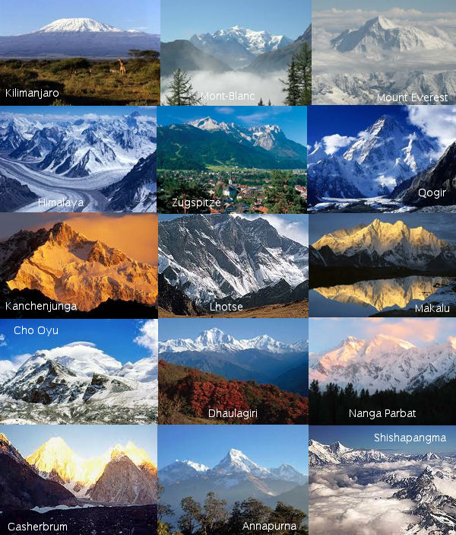
How to make a mountain

Fold Mountains

- You have 2 slices of bread flat in front of you, side by side.
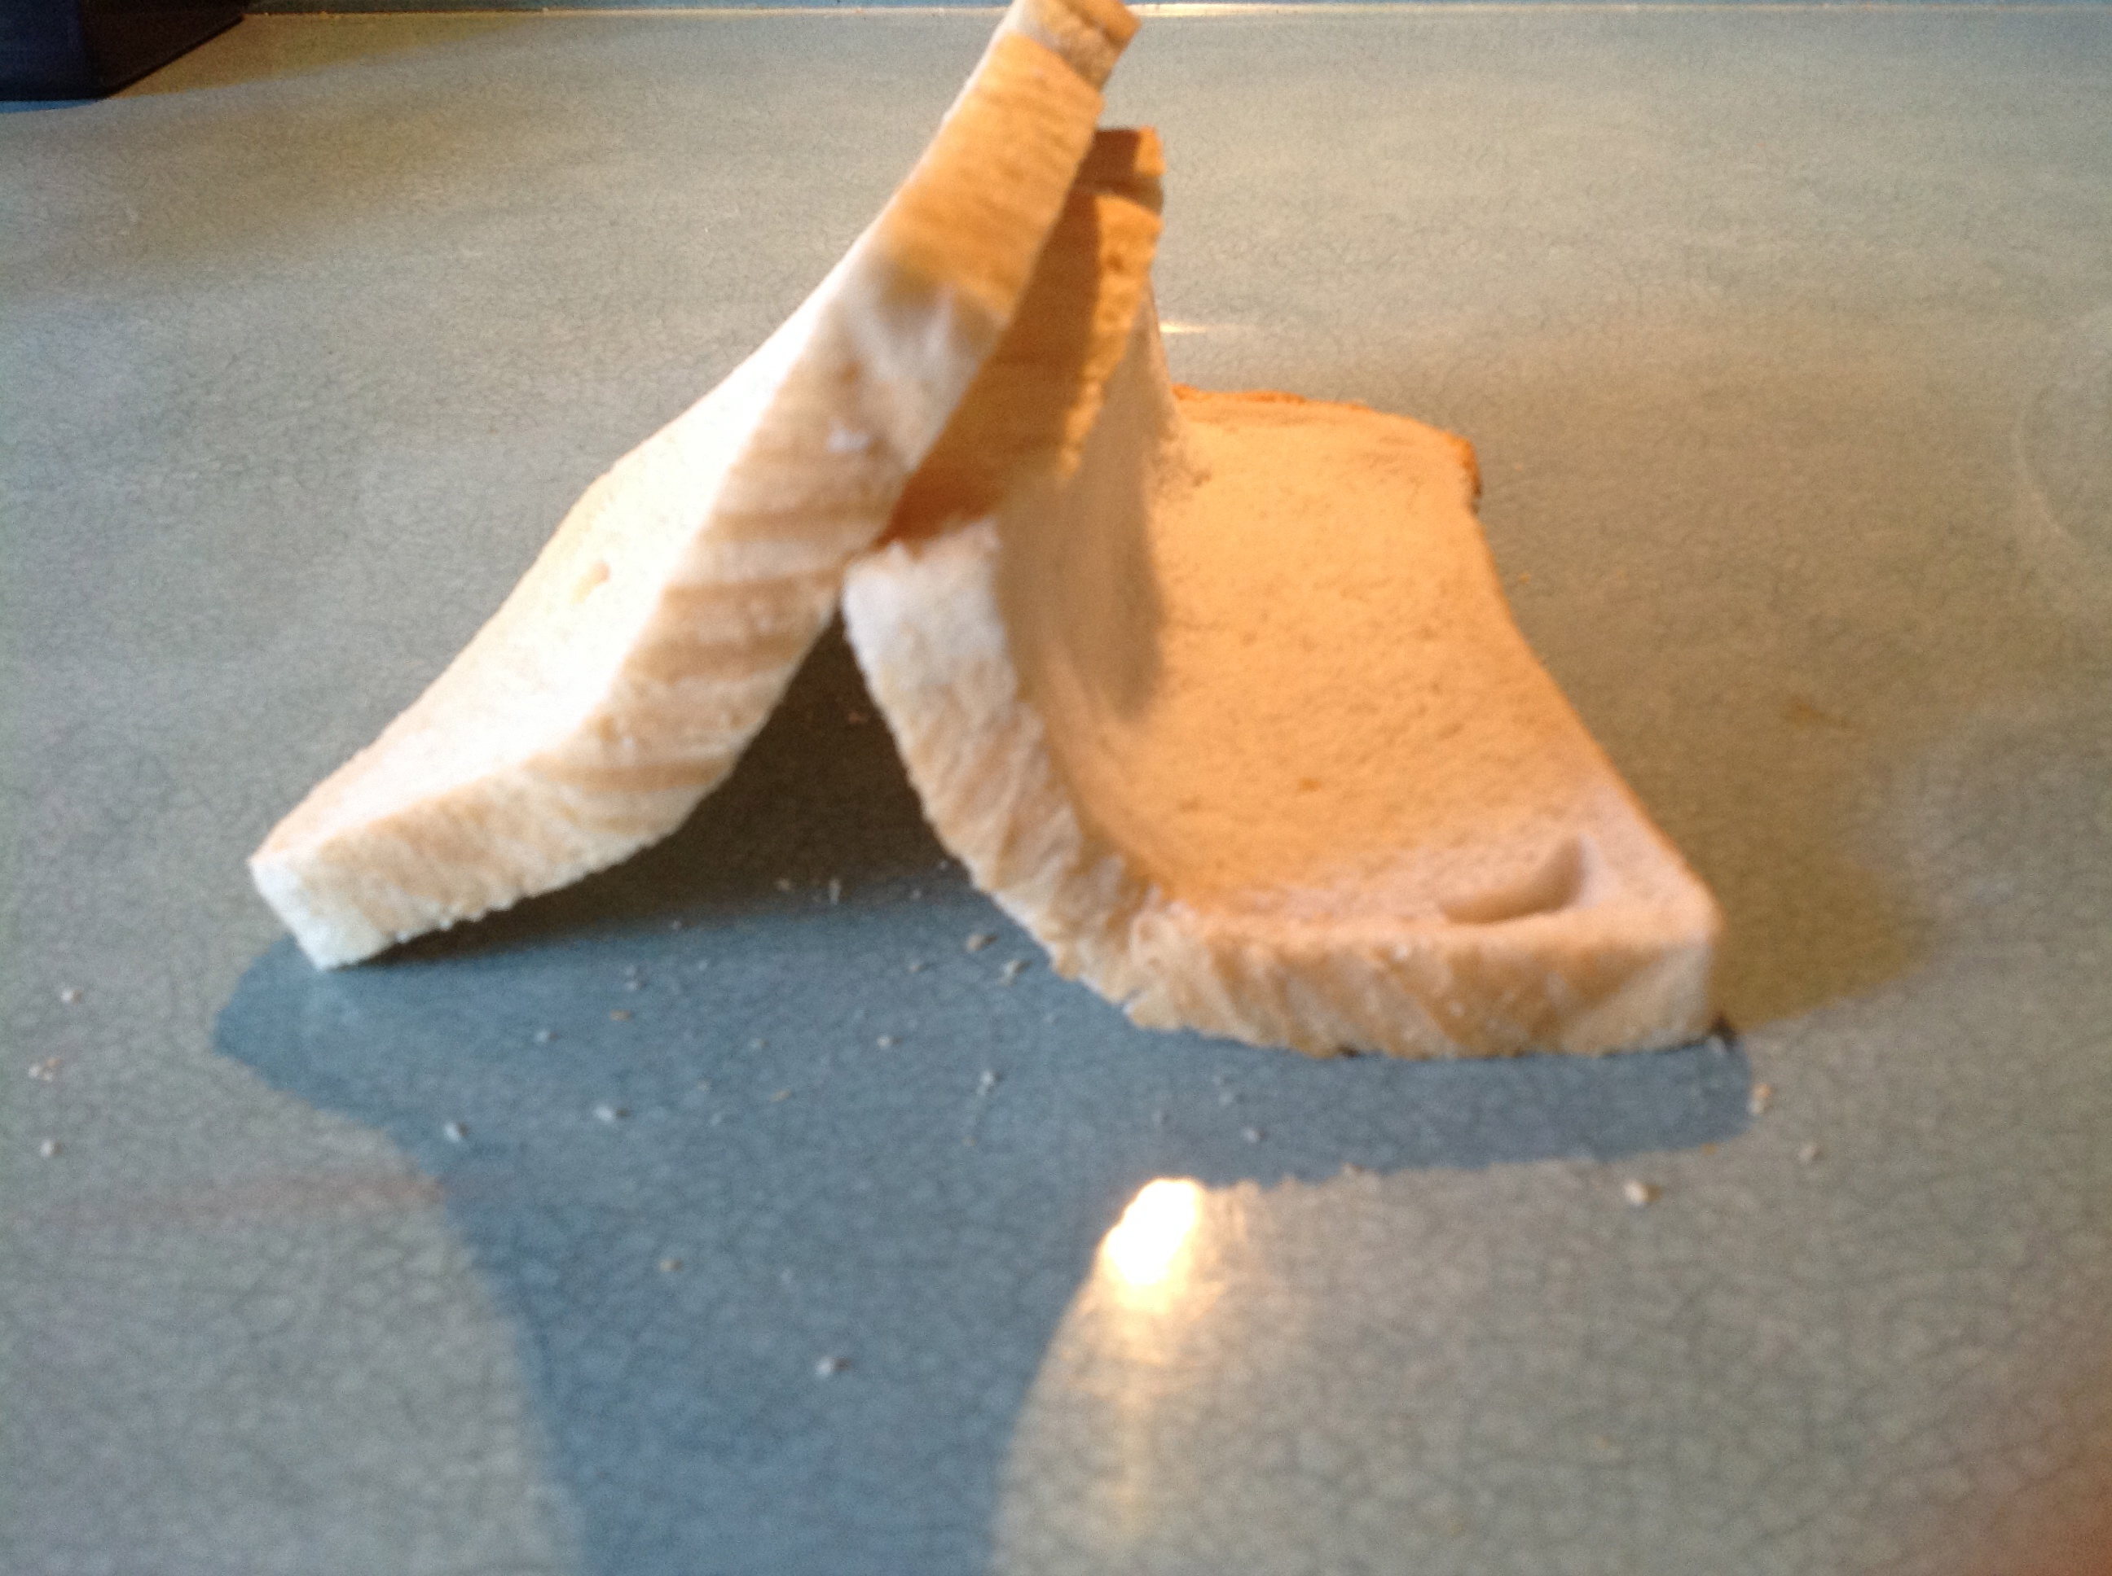
- Push from the outside of each slice of bread together in until they make a fold.
- How easily do they fold?
- What kinds of fold do they make? (When the two ‘plates’ collide, the edges crumble)

Fault-block Mountain

- You have a cream cracker slab that represents the rocks in the earth’s plates. Break it in half.
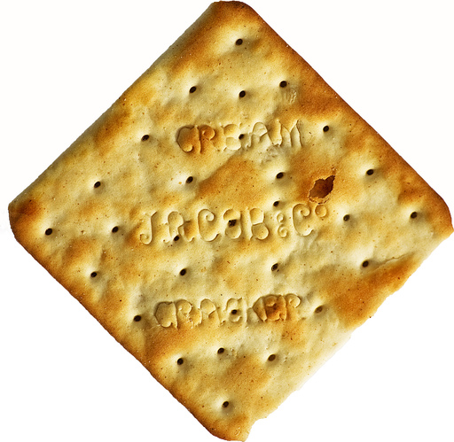
- What happens to the ‘rocks’ in the middle?
- Have all the ‘rocks’ moved downwards?
- How many have moved upwards?
- What would happen if you tried to push the plates back together again?
(These mountains form when faults or cracks in the earth's crust force some materials or blocks of rock up and others down.
Instead of the earth folding over, the earth's crust fractures (pulls apart). It breaks up into blocks or chunks. Sometimes these blocks of rock move up and down, as they move apart and blocks of rock end up being stacked on one another).

Dome Mountain

You have tissues, material and a balloon. Stretch the tissue out and find the small surface hole in the tissue. Begin to feed through your balloon.
Note very carefully what it look like as it breaks through the surface.

- Begin to blow up your balloon slowly
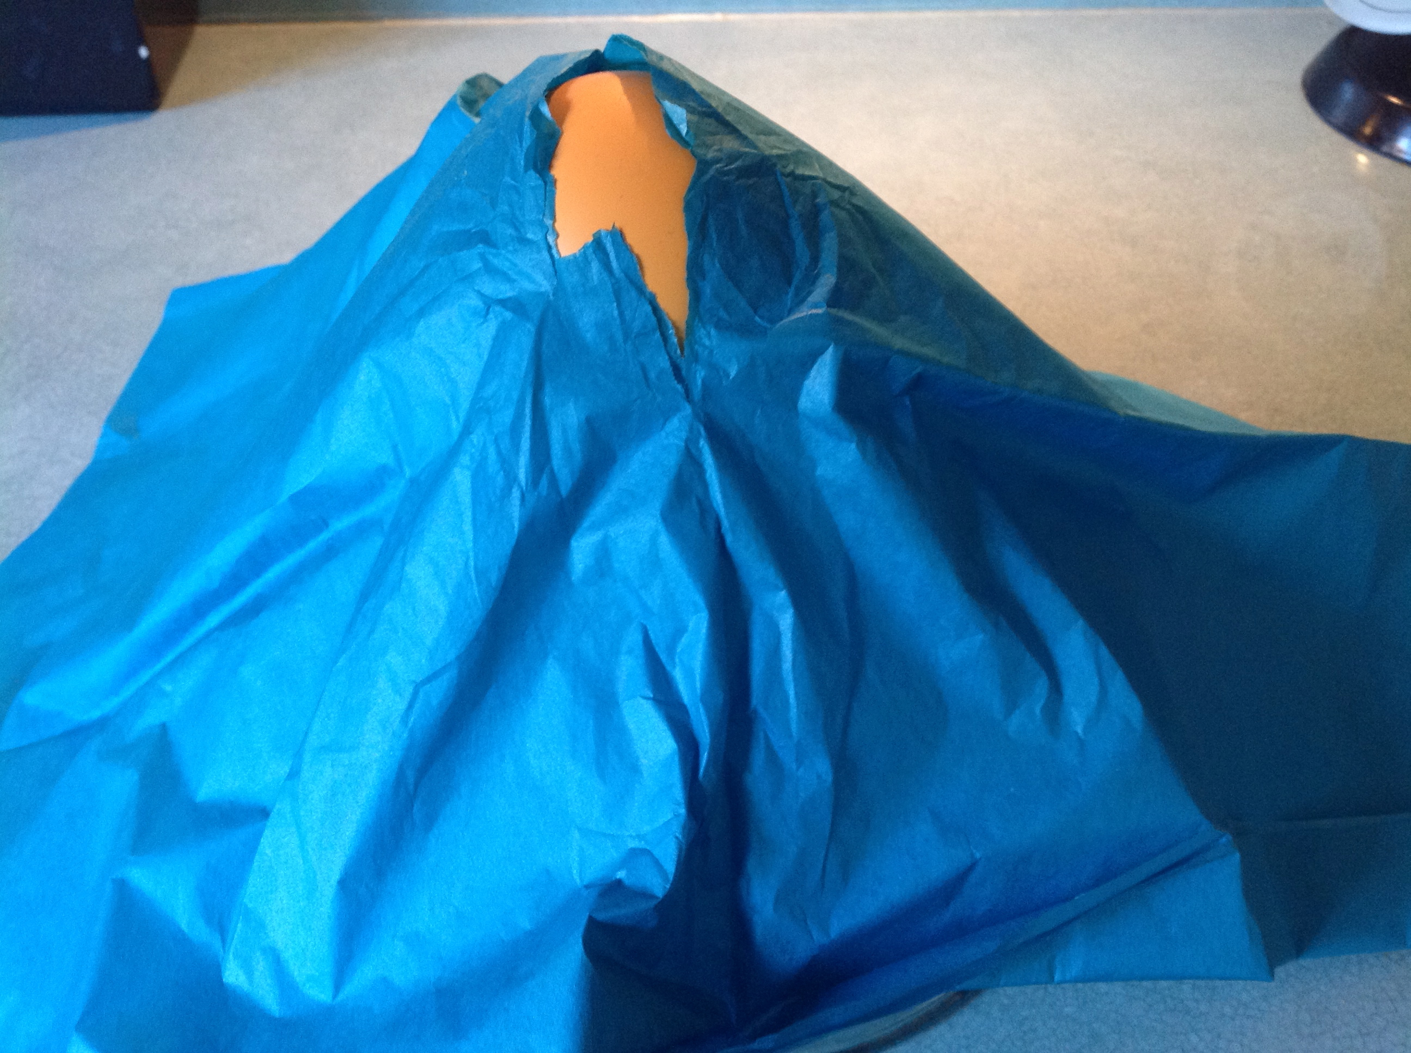
What happens to the tissue?
What happens to the balloon?

- Try the same thing with the material
What happens to the balloon?
What happens to the tissue?

(Dome Mountains are the result of a great amount of melted rock (magma) pushing its way up under the earth crust. Without actually erupting onto the surface, the magma pushes up overlaying rock layers. At some point, the magma cools and forms hardened rock. The uplifted area created by rising magma is called a dome because of looking like the top half of a sphere (ball). The rock layers over the hardened magma are warped upward to form the dome. But the rock layers of the surrounding area remain flat).

Volcanic Mountain

- You have tin foil and a bag with red icing in it.
- Put the tin foil flat across the icing bag then slowly move the bag upwards. Make a small hole in the foil and release the icing.
- What happens?
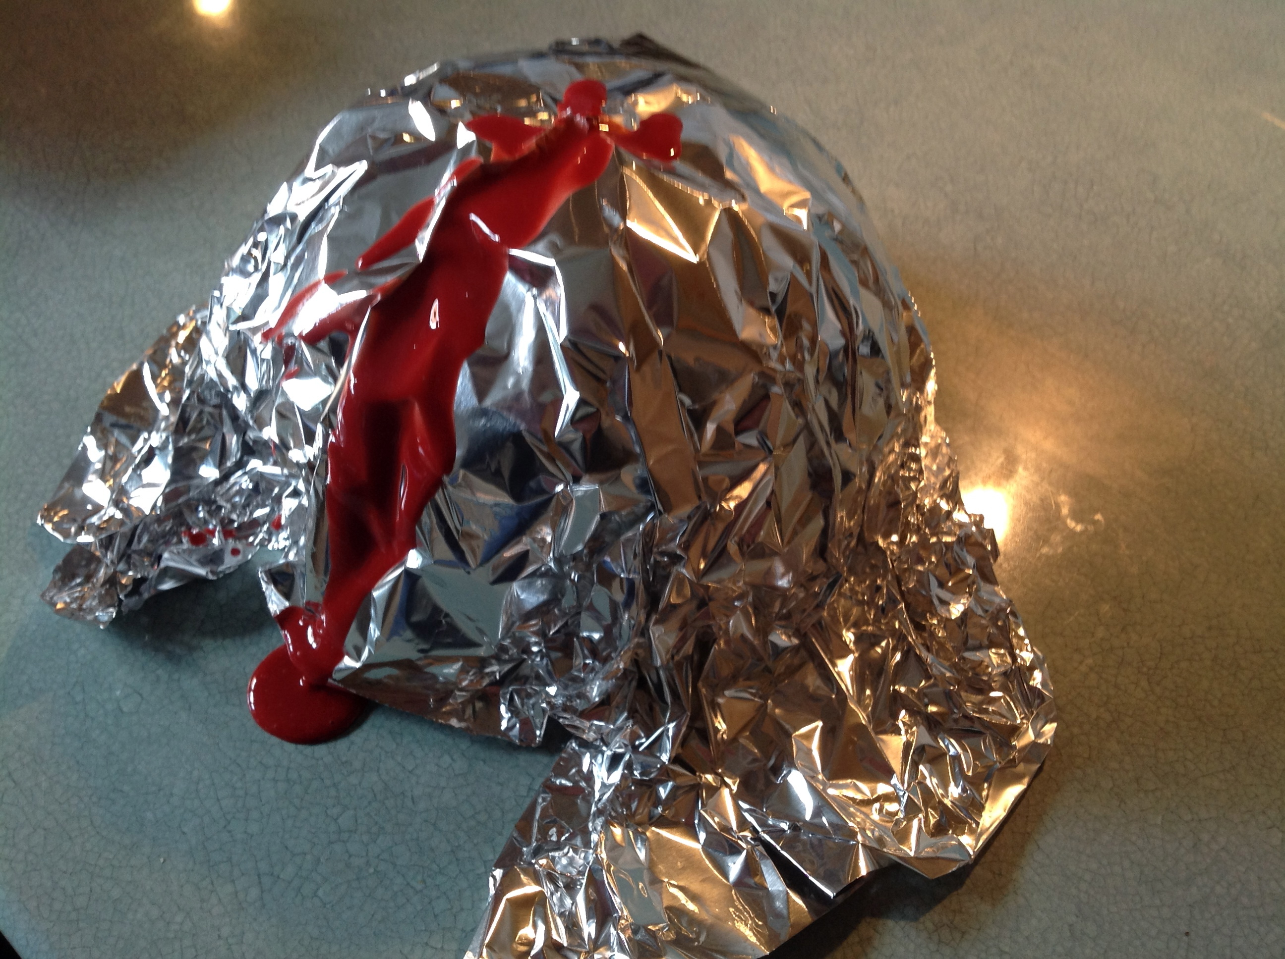

- Does the icing stay in one place?
- What will happen if the icing dries?
- What will happen if the icing is then pushed out again?
- What happens to the tin foil?
- What happens to the icing?
(Volcanic Mountains are formed when molten rock (magma) deep within the earth, erupts, and piles upon the surface. Magma is called lava when it breaks through the earth's crust. When the ash and lava cools, it builds a cone of rock. Rock and lava pile up, layer on top of layer).

Plateau Mountains

- You have some blocks, a tray of sand, a larger tray and a jug of water.
- Put the tray of sand inside the larger tray.
- Put your blocks so your tray of sand is slightly higher at one end than at the other.
- Slowly pour the water into the higher end of the sand tray.
- What happens to the sand?
- What happens to the water?
- If you carried on pouring the water what would happen?
(Plateau Mountains are not formed by internal activity. Instead, these mountains are formed by erosion. Plateaus are large flat areas that have been pushed above sea level by forces within the Earth, or have been formed by layers of lava).
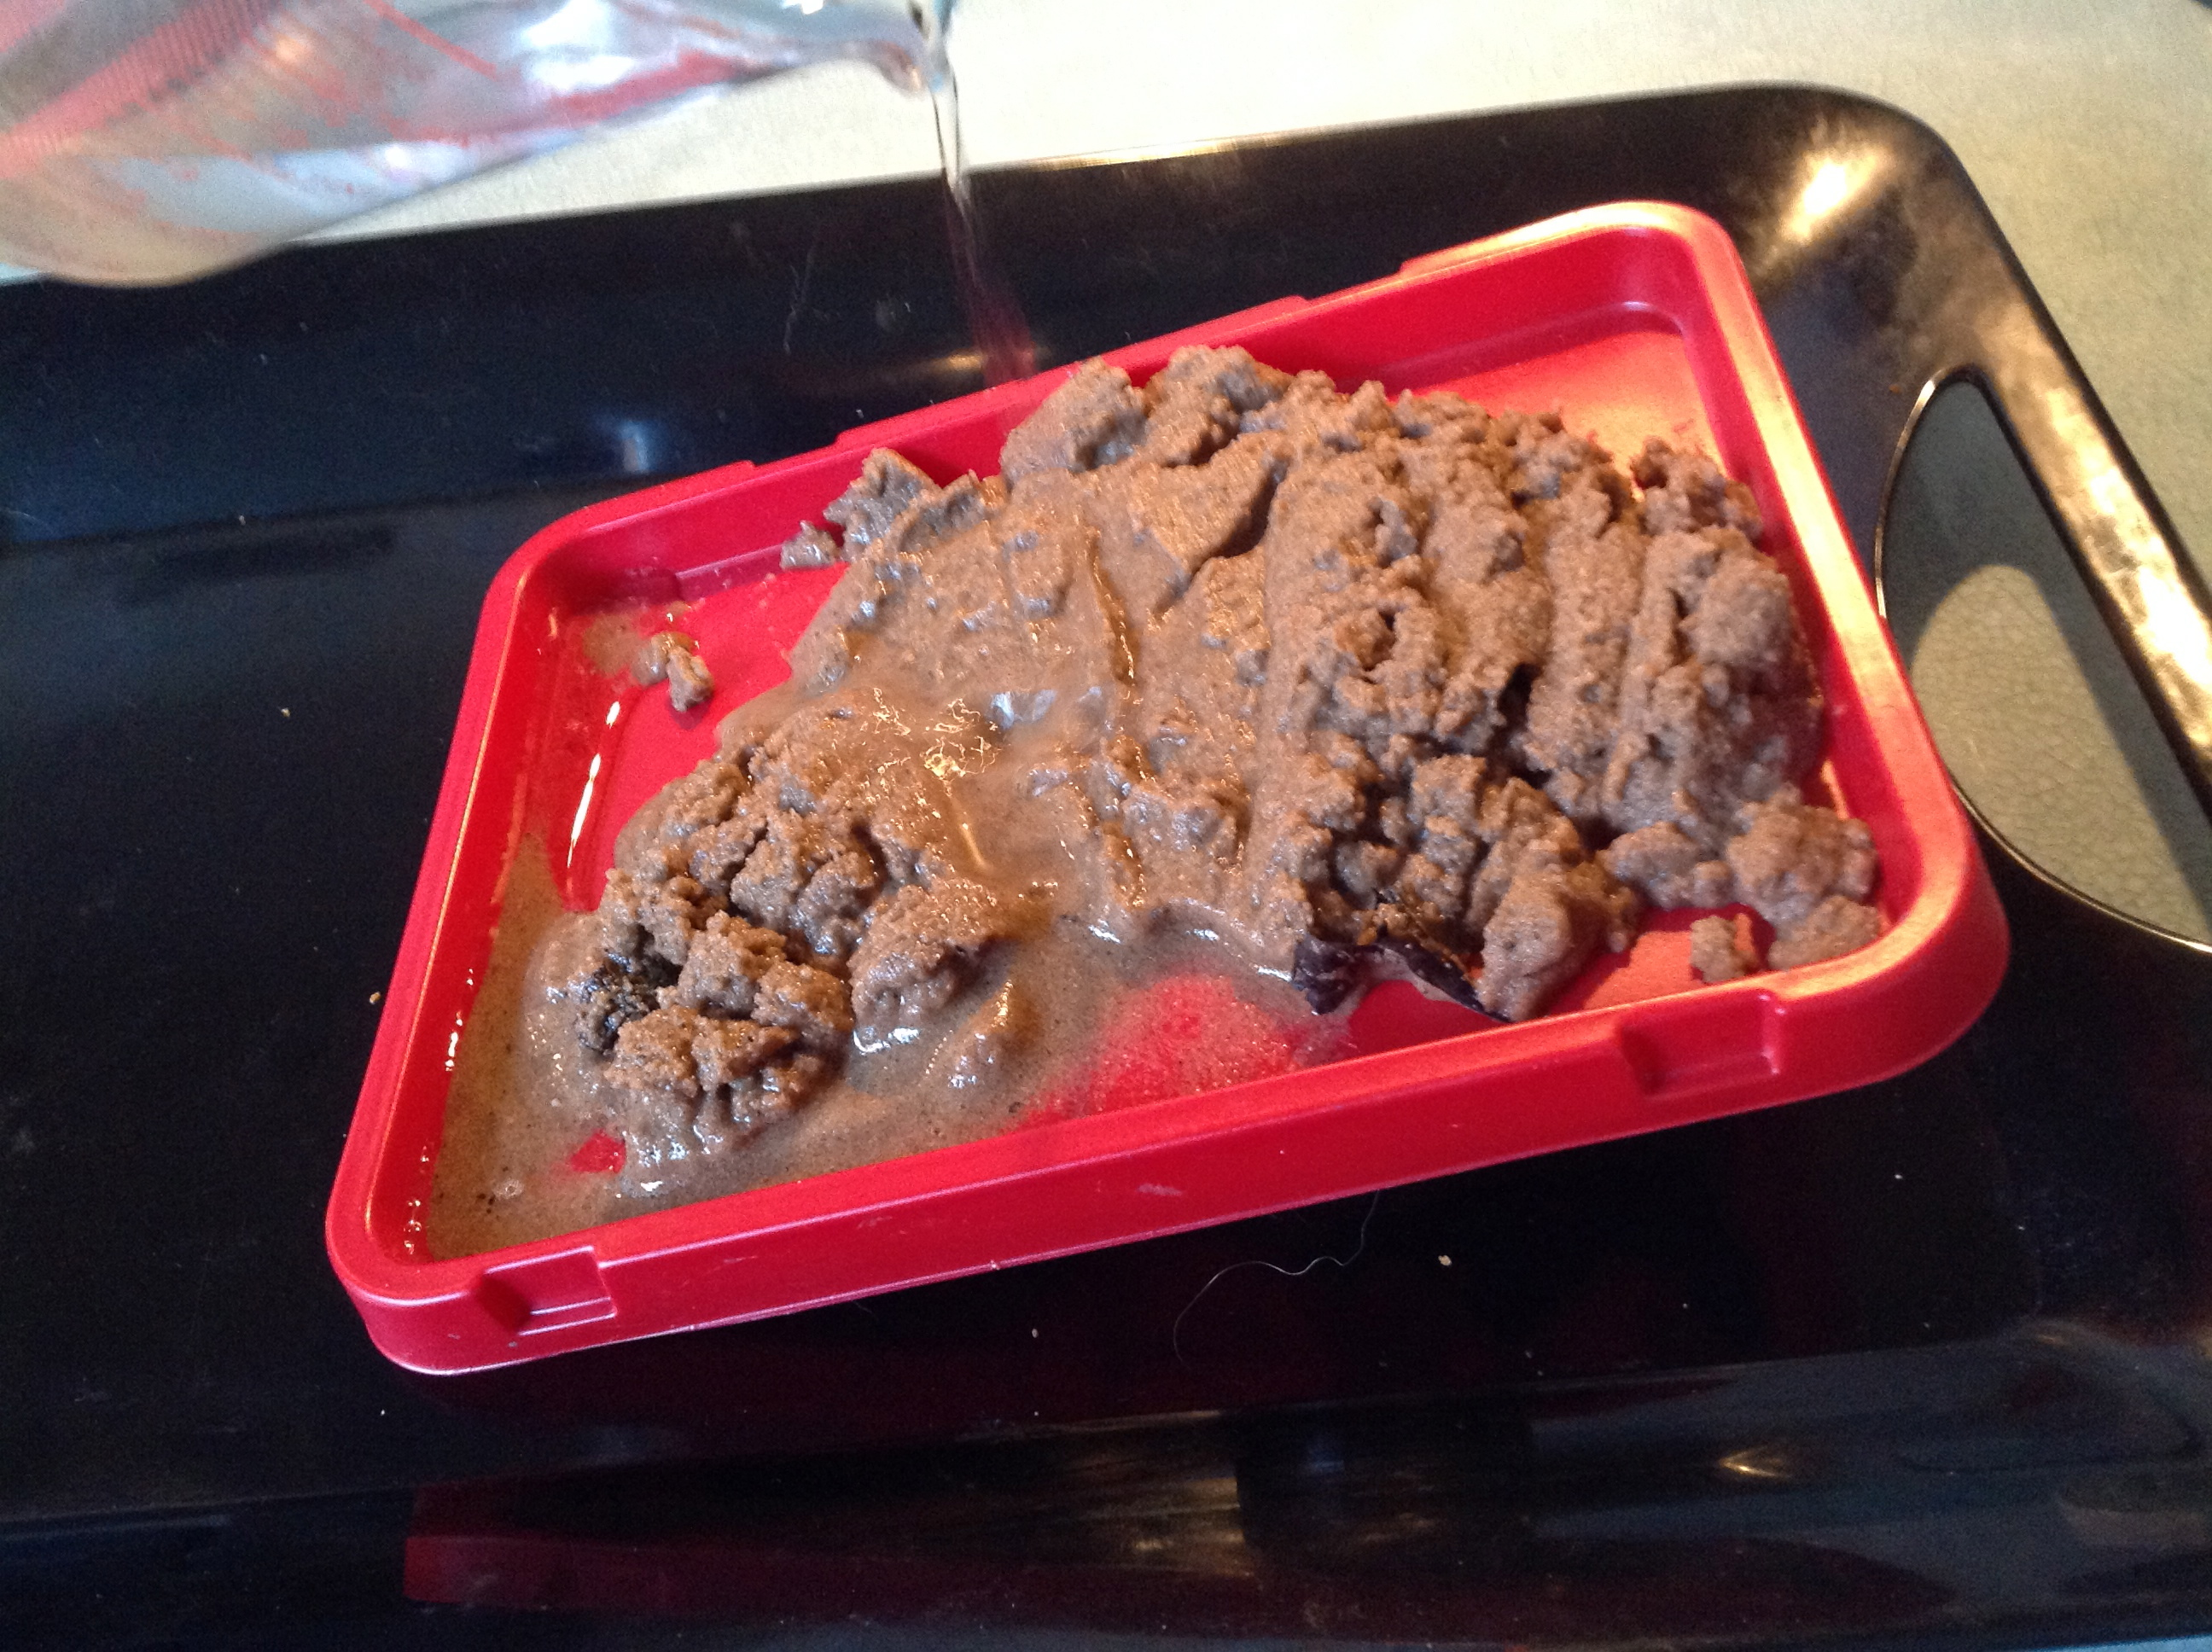
T: to know how mountains are formed
- Must: identify different types of mountain
- Should: explain the difference between types of mountain
- Could: describe how different mountains are formed

Fold Mountains

Fault-block Mountains

Dome Mountains

Volcanic Mountains

Plateau Mountains



