Guided Reading – Medium Task
Watch ‘The Tin Forest’, http://www.lovemybooks.co.uk/the-tin-forest. Now read the text for yourself in the attachment. Find 5 nouns and 5 verbs.
Discuss and record some answers to the questions below.
- What animals and plants can you see?

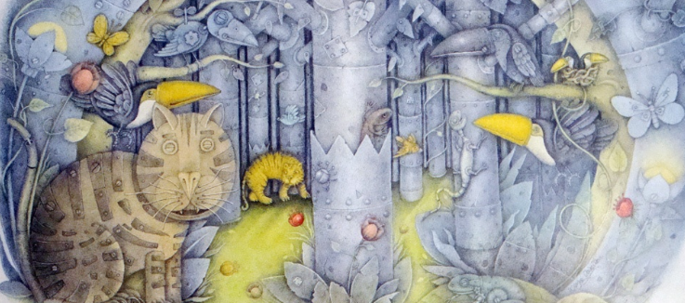

- How does the forest change? What stays the same?
- Do you like or dislike the story? Explain your answer.
- How does the man feel at the beginning of the story and at the end? What feelings change, what feelings stay the same?
- What do you wonder about the story? What puzzles you?
- The old man made animals beginning with ‘t’, why? Think of more animals beginning with this letter.
Challenge
Draw or build your own dream forest. Use what you have been learning in your writing lessons this week to write a setting description for your dream forest.

