Guided Reading – Mild Task
Watch ‘The Tin Forest’, http://www.lovemybooks.co.uk/the-tin-forest
Discuss and record some answers to the questions below.
- What animals and plants can you see?

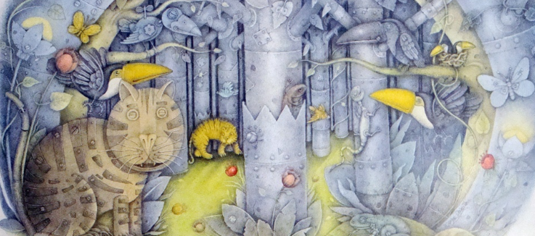

- How does the forest change? What stays the same?
- Do you like or dislike the story? Explain your answer.
- How does the man feel at the beginning of the story and at the end? What feelings change, what feelings stay the same?
Challenge
Draw or build your own dream forest. Use what you have been learning in your writing lessons this week to write a setting description for your dream forest.

