Wednesday Mild
1, Copy the sentences and fill in the blanks with the words below.
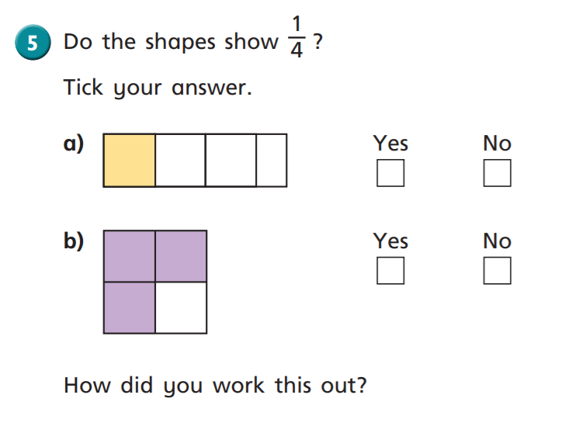
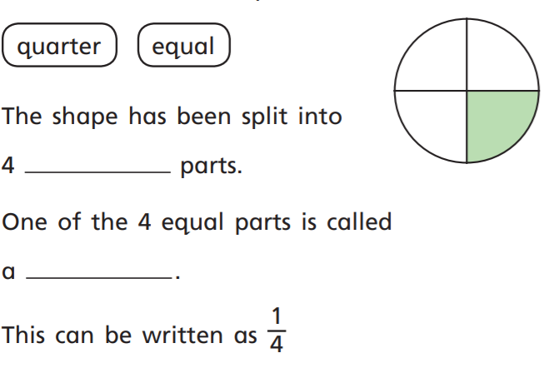
2. Circle the object showing ¼.
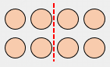



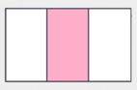

3.

Medium/Spicy
- 2.
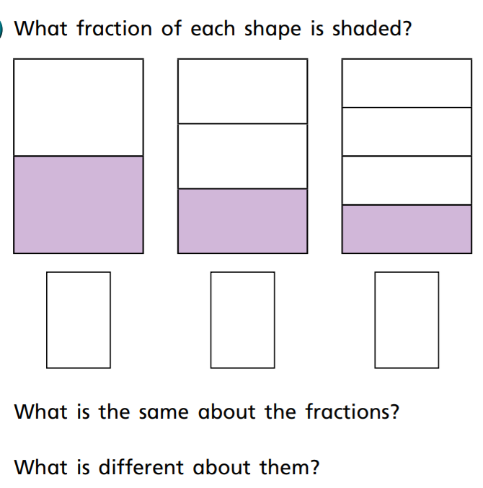
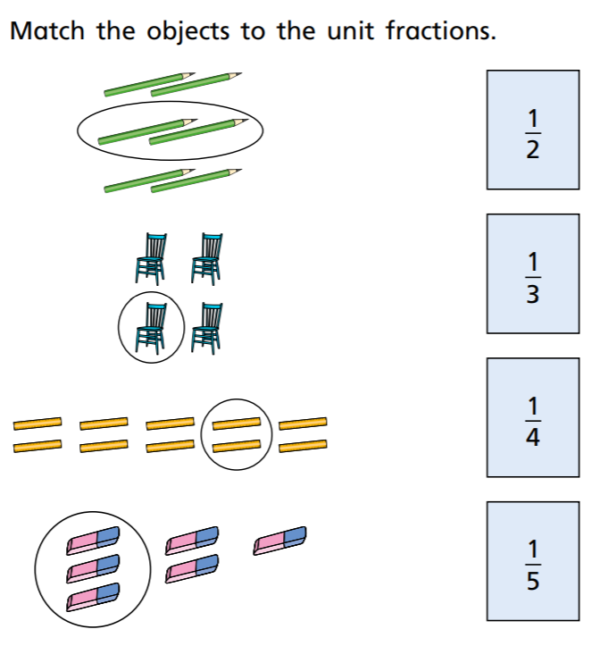
3.
Find the fraction of the ribbon. Show your work.

Ribbon Length | ½ | 1/3 | ¼
12 cm
24 cm
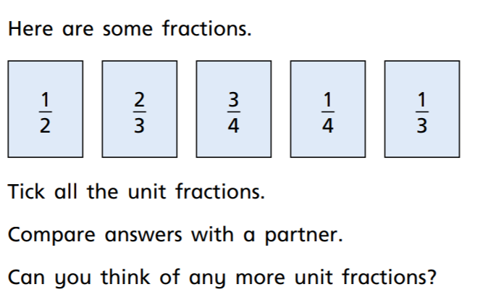
4.

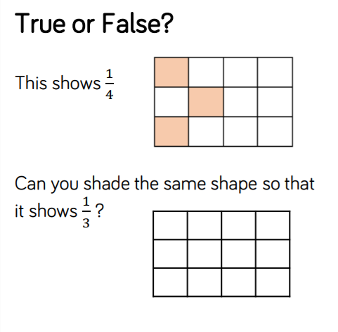
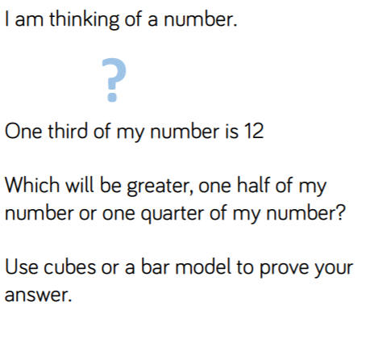
5. 6.

