Tuesday Mild Challenge

Draw the shapes and shade ½ of each.

Circle ½ of the stars. Circle ½ the faces.

For this part you will need objects to count! You can use anything you have at home (pasta, lego, sweets)

Share 8 counters equally between two containers, then complete the stem sentences.

The whole is ____. Half of ____ is ____.

Share 10 counters equally between two containers, then complete the stem sentences.

The whole is ____. Half of ____ is ____.

Share 20 counters equally between two containers, then complete the stem sentences.

The whole is ____. Half of ____ is ____.

Medium/ Spicy Challenge:

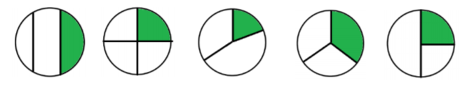
Circle which shape shows a third.

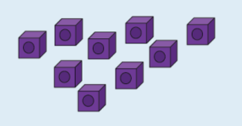
Use the cubes to make 3 equal groups.
There are …………. cubes altogether.
One third of …… is ……..
This can be written as one third of
9 is ……….
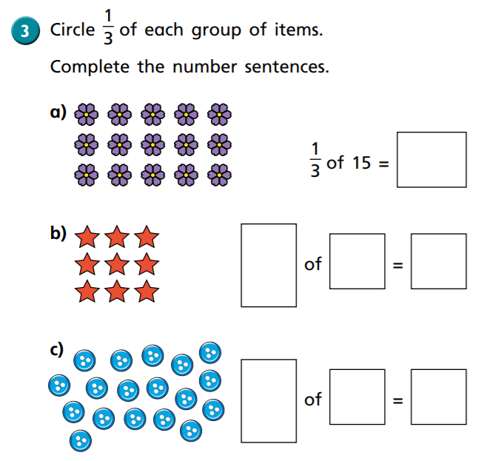
Use cubes or counters to help you find a third.



