Thursday Mild- use objects at home to help you!
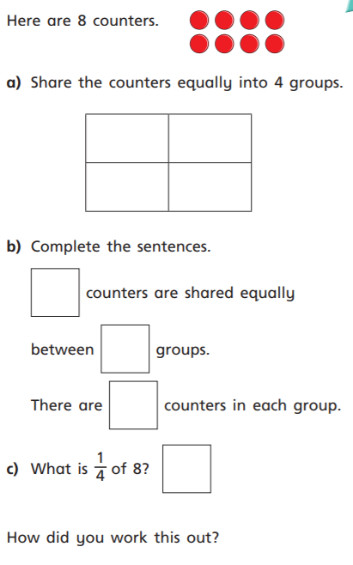
1.

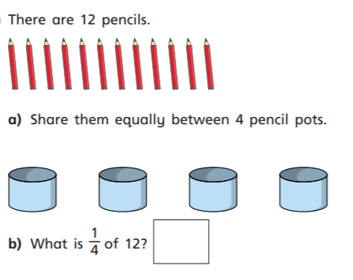
2.

Medium/Spicy
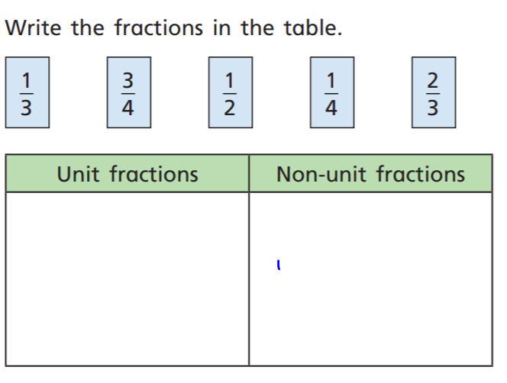
1.

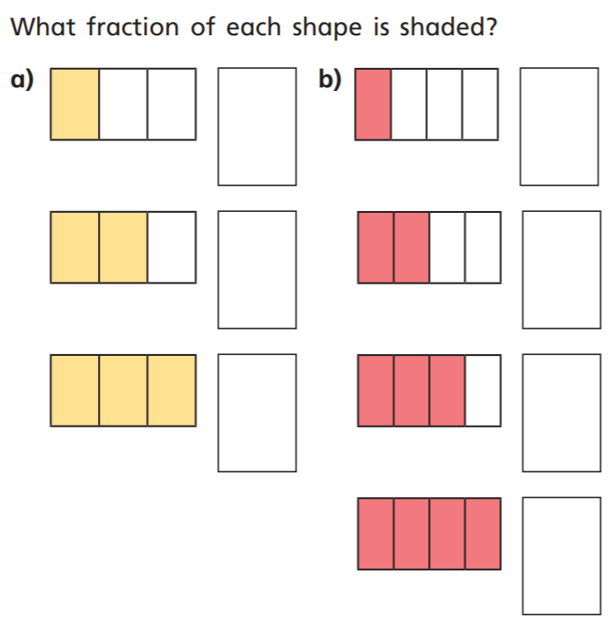
2.

3. Find the fraction of the following:

½ of 12 ⅔ of 15 ¼ of 16

¾ of 24
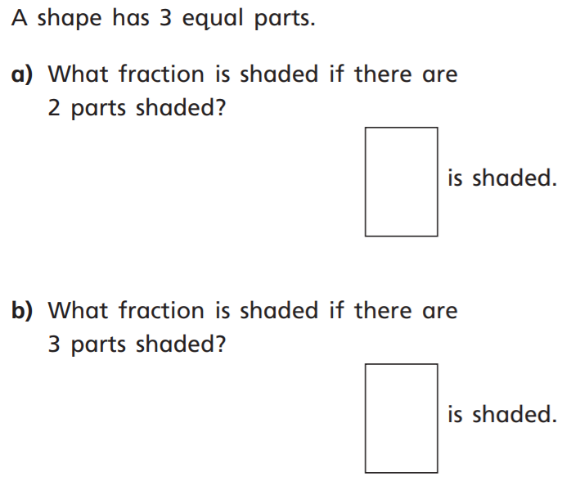
4.

