Monday Fractions home learning task

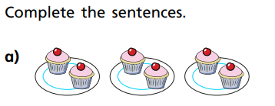

There are ____ groups of ___.

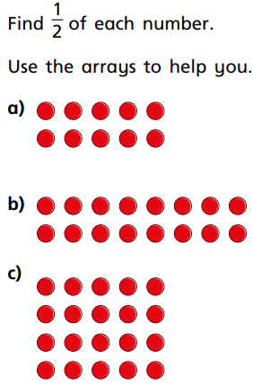

½ of 10 = _______

½ of 16 = _______

½ of 20 = _______

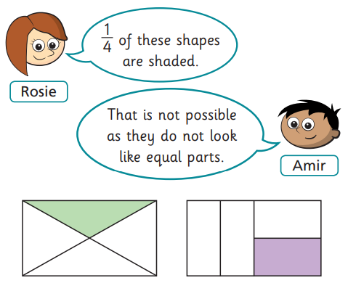
Who is correct?

Type your answer here:

How do you know?

Type your answer here:

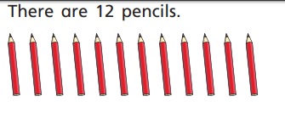
What is ¼ of 12? _____

Answer the questions below (you could use a pen and paper to help you):

½ of 20 = _______

¼ of 24 = _______

¼ of 8 = ________

½ of 14 = ________

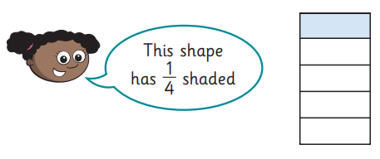
Do you agree with Whitney? Why?
Type your answer here:

Challenge: Which one is bigger? ½ of 20 or ¼ of 20? ___________

How do you know: Type your answer here.

