Friday- Mild
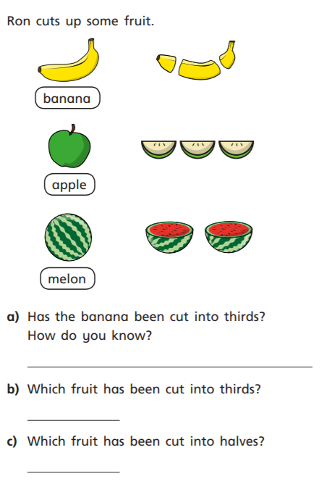
1.

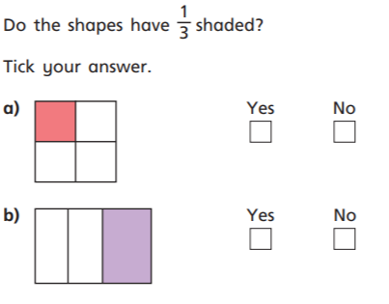
2.

3. Use objects at home to help you share into three equal groups.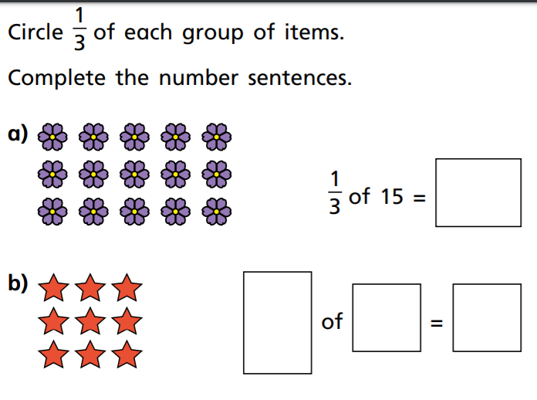

Medium/Spicy
Solve the following problems using the skills we have learnt about fractions. Don’t forget to work out your answers and show your work!!
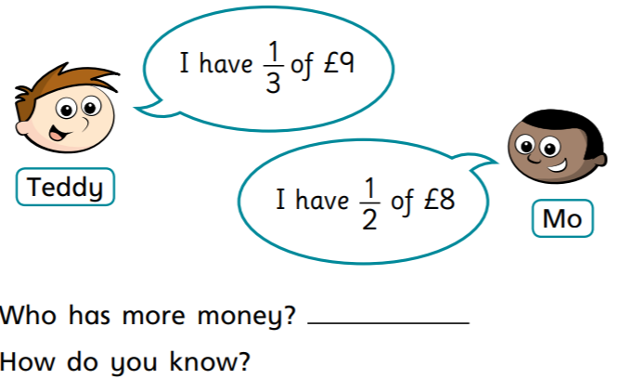
1.

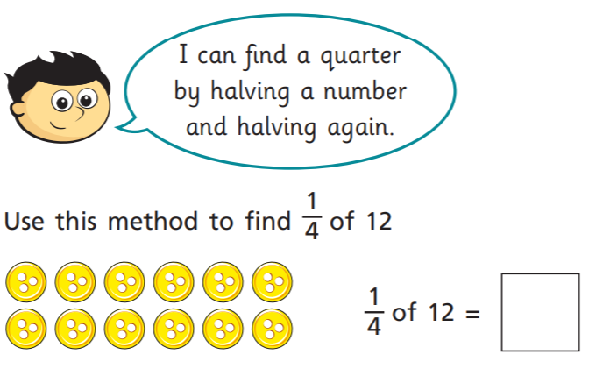
2.

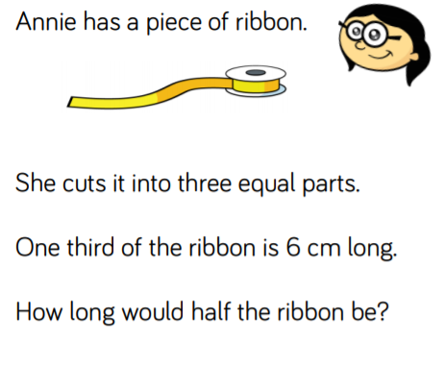
3.

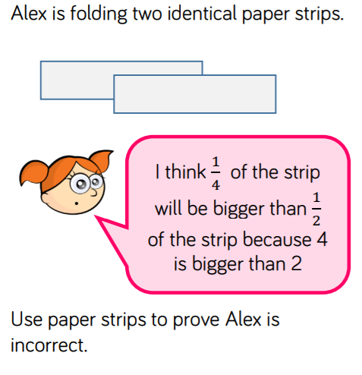
4.

5. Tommy has 48 Pokémon cards. He gives 2/4 to Jacob. How many does Jacob have?

6. Mrs Robitaille reads for 24 minutes.
- Miss Williams reads for half of that time. How many minutes does Miss Williams read for?
- Miss Hignett reads for half the amount of time Miss Williams does. How long has she read for?

