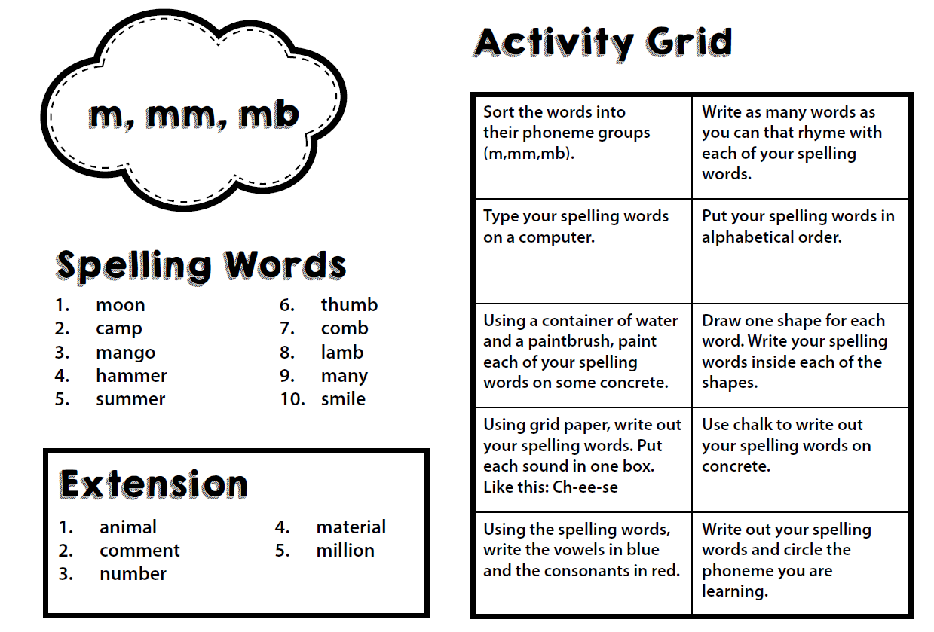
All Children:

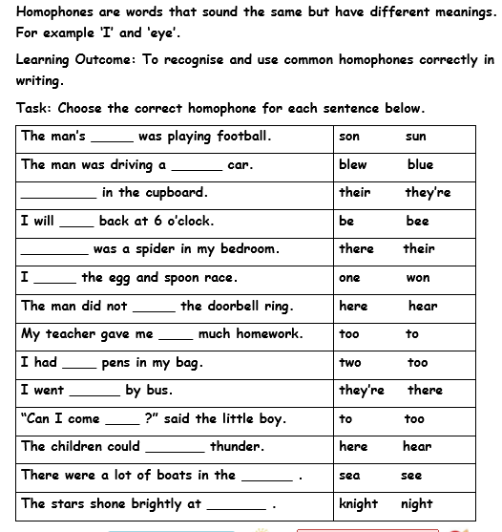
Mild:

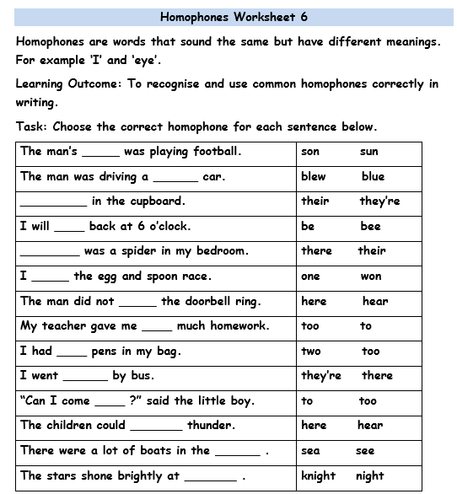
Medium/Spicy:
Mild: Changing singular nouns to plural nouns
Remember the rule!
Nouns ending in
x, z, s, sh, ch form the plural by adding es to the end!
Can you add ‘s’ or ‘es’ to each word to make it a plural?
cat ______
bush ______
match ______
witch ________
train ________
goat _______
class _______
box ________

Ext: Can you write a sentence using one of the plurals?
_____________________________
_____________________________

Medium: Changing singular nouns to plural nouns
Add s or es at the end of each word to form the plural.
Remember the rule!
Nouns ending in
x, z, s, sh, ch form the plural by adding es to the end!
- flower _________
- box _________
- flash __________
- lunch ___________
- peach ___________
- wish ___________
- class __________
- tree ________
- church __________
- apple __________
- fox __________
- egg __________
- waltz __________
- cloud __________

Spicy: Changing singular nouns to plural nouns
Change these singular nouns into plurals by writing them in a sentence with a plural noun.
- church There are three large churches in our village.
- crash
- box
- class
- truck
- beach
- waltz
- blanket

