WB: 27.4.2020 Medium/Spicy worksheets

Remember, all of these activities can be copied onto paper. You do not need to print out the worksheets.

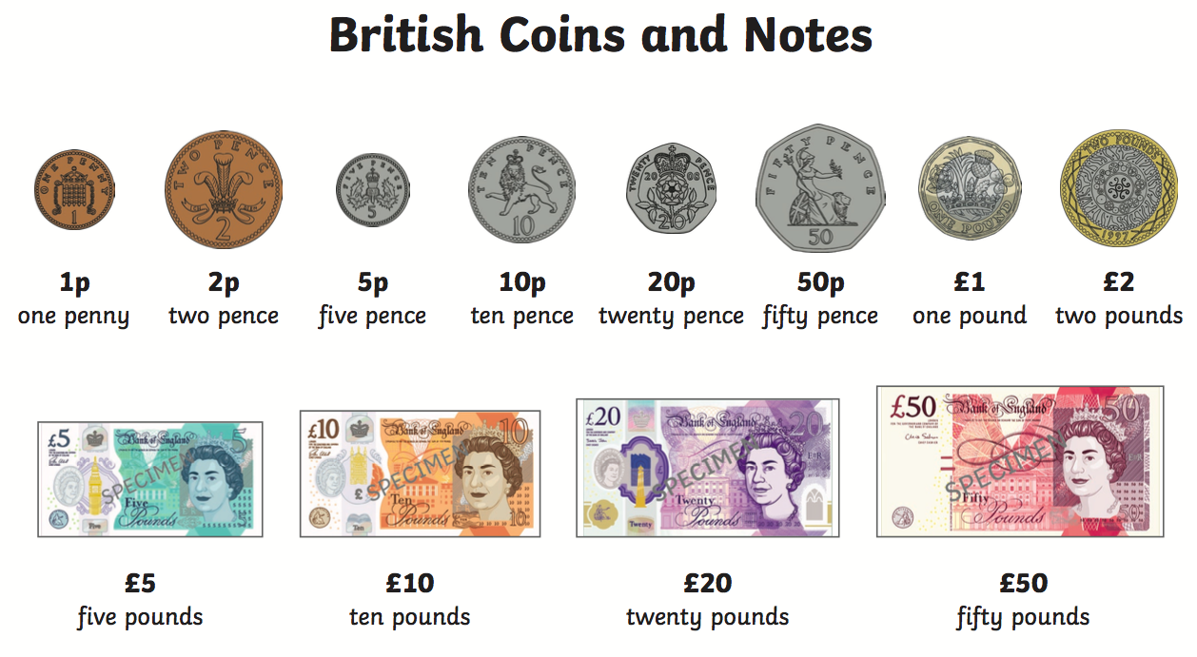

Monday:
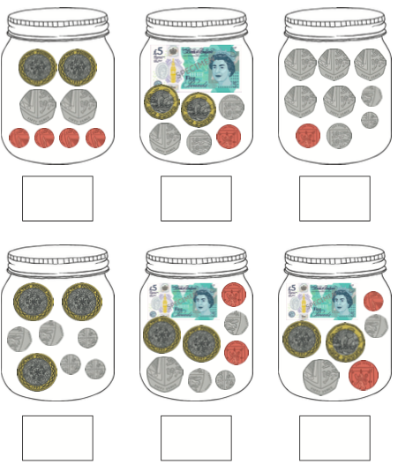

Tuesday: On a piece of paper, draw the coins that would make the amount.
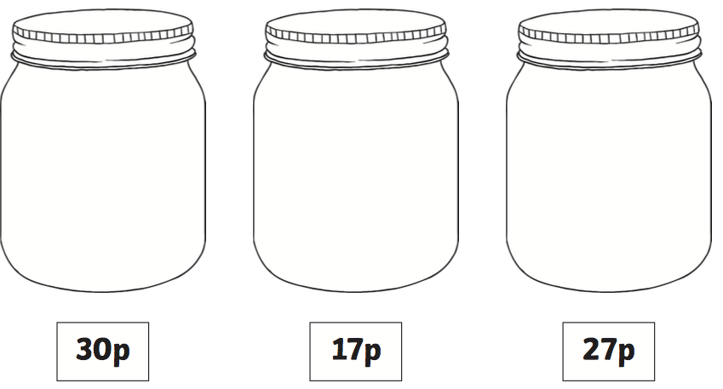

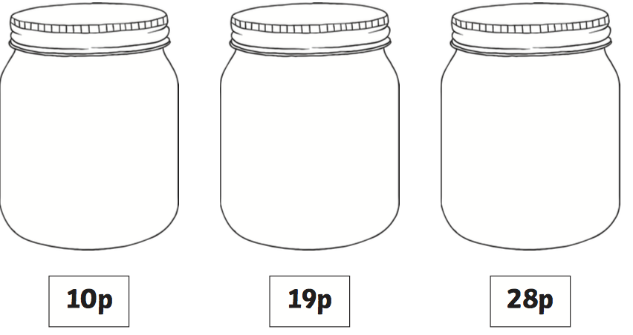

Thursday:

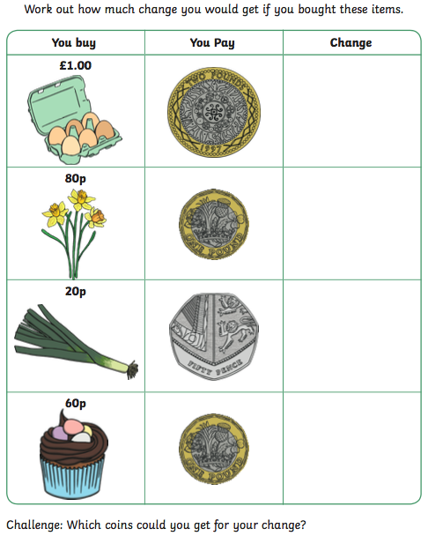
Friday:


