WB: 27.4.2020 Mild worksheets.

Remember, all of these activities can be copied onto paper. You do not need to print out the worksheets.

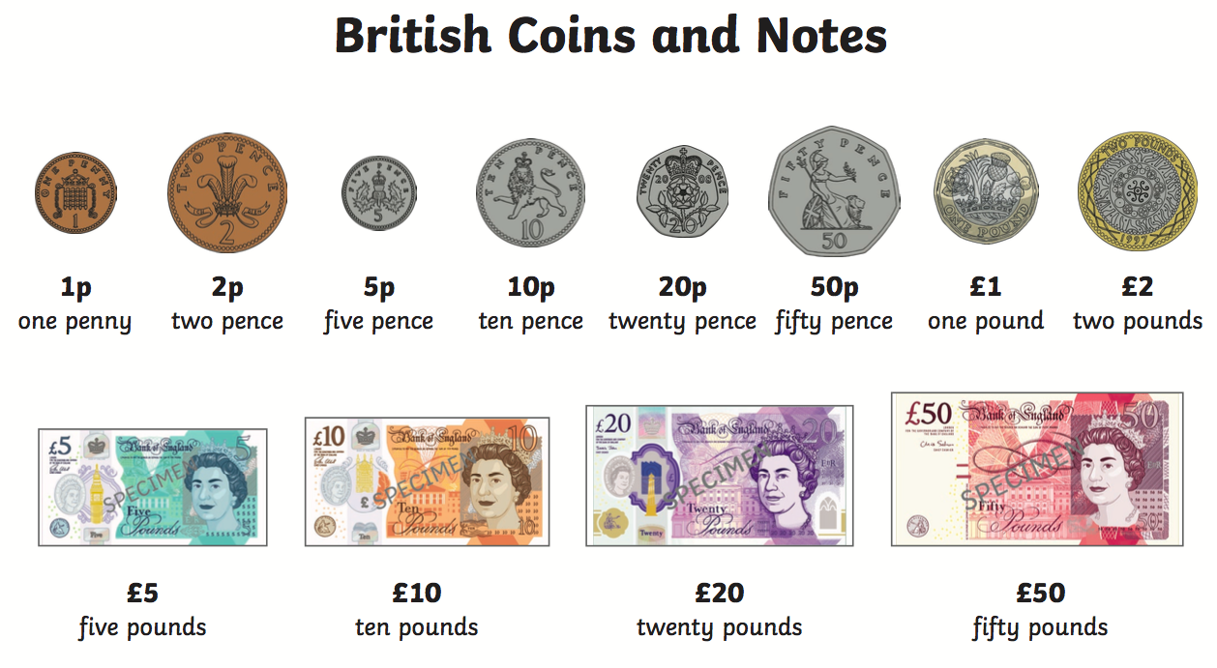

Maths, Tuesday:
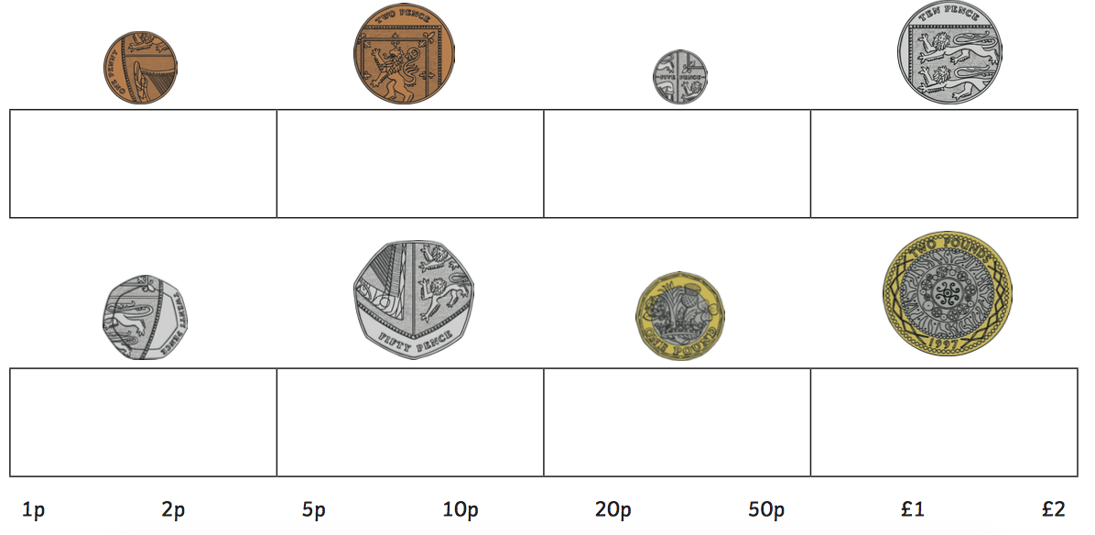

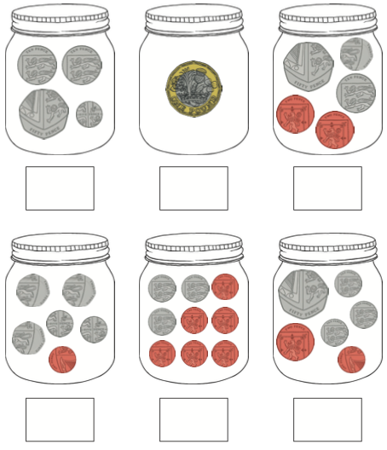
Maths, Thursday:

Friday:



