We will set tasks for you to complete but would like you to submit task 3 for us to mark.
Task 1: Share the story with a grown up and complete the four sentences. If your child find this tricky see the document, ‘ with help’.

The May Ball – Fitz and Will the Cambridge Cats
Main story – we would normally create a text map of our story and make up actions to help us learn the text. Key words have been highlighted.

Fitz and Will - The May Ball Adventure adapted for Talk For Writing

One warm evening, Fitz and Will lay stretched out in the sun. Their museum was closed so they set out into town for some fun.
First they scampered around until they reached the crested gates of Trinity College.
Inside they could see people dancing to music and chatting away.
Next the curious cats climbed up high onto the roof… Crash! Unfortunately they knocked over some flowers.
Then they padded into the kitchen...Whoops! Unfortunately they knocked over a tub of cream!
After that the naughty cats continued to explore. They came to a beautiful cake standing tall. Will put out his paw so that he could touch the cake and…SPLAT! Unfortunately the cake collapsed. The cats ran as fast as they could and jumped onto a bouncy castle.
Fortunately they landed in a punt on the river.
Finally resting back under the stars, the cats thought about their mischievous May Ball adventure.
Opening
Middle
Ending
Share the story with a grown up and talk about the plot, what happened. Now complete our sentences.
I liked

My favourite part was

I was surprised at

Next time I would like Fitz and Will to

Task 2: We would like you to point to each of our sentence openers in the text. Then look at the box below, explain what each word means. If you are not sure, use the Tools tab and click onto the dictionary.
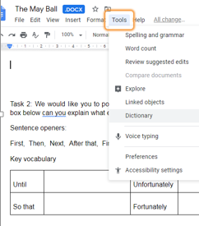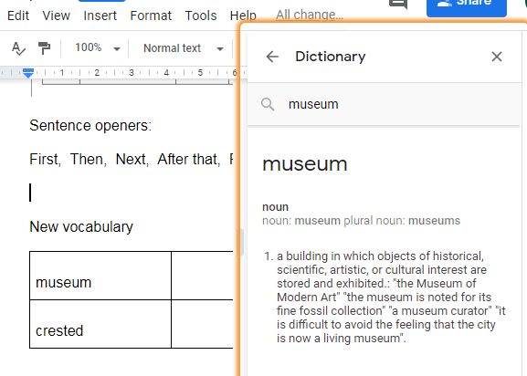
Sentence openers, we have learnt these for other texts.
First, Then, Next, After that, Finally
Task 2: look up each word, write a short explanation for each word.
New vocabulary
museum
crested
resting
adventure
mischievous
collapsed
scampered

Task 3: this is the task we would like you to send to us. Use at least 3 of the words: museum, crested, resting, adventure, mischievous, collapsed, scampered.
Now write your own sentences, this will show us you understand the meaning. Extension task - use adjectives, and, or, because.
Task 4, Please learn this rhyme, can you put some actions to this rhyme?
Hey diddle diddle the cat and the fiddle
The cow jumped over the moon.
The little dog laughed to see such fun
And the dish ran away with the spoon

Task 5: optional.
This is our example:

Year One VE Day Tea Party
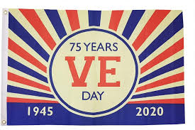
To Mrs Dalton,

You are invited to our Year One VE Day Tea Party,

On Friday 8th May at 3:00pm until 5:00pm
At Trumpington Park
Please bring your own rug, to sit on. You need to bring a sunhat and water bottle.

From Year One

R.S.V.P.
(Please reply to us)

Fitz and Will need to write an invitation to The May Ball, can you help them put the invitation in order? (This will not happen as we are in lockdown)

R.S.V.P. (please reply)
From Year One
Friday 8th May at 3.00pm until 5.00pm
Dear Mrs Dalton
Please bring your own rug.
At Trumpington Park
Please bring a sunhat and water bottle.

