Maths Challenge Tasks 4th – 7th May
You do not have to print these out, just say or write the answer.
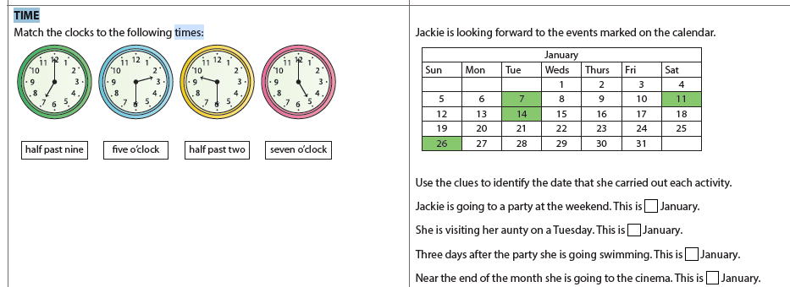

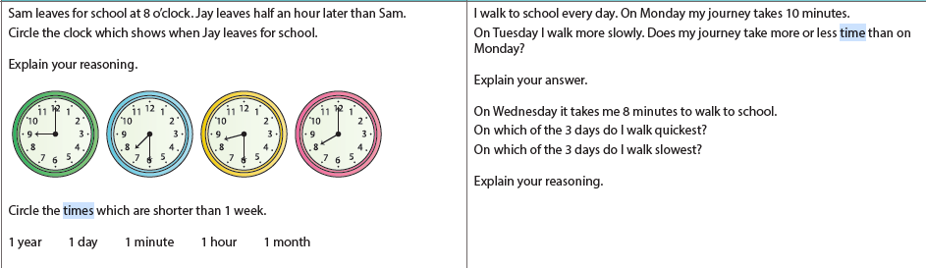

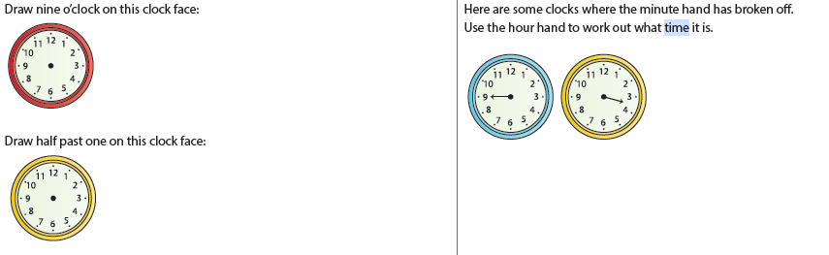

Challenges from last week’s learning


