Science – make your own table, draw your birds and then enjoy counting them. You could use a tally chart, I have given you the key vocabulary but not named each bird, you can choose how many birds you want to do.
Bird name | Tally | total
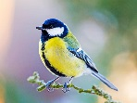 | 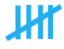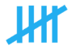 | 11
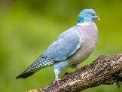 pigeon | 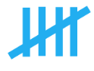 | 6
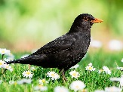 |  | 2

I am very lucky to have a garden and I have seen:
Great tits, blue tits, magpies, wood pigeons, blackbirds and robins.
If I walk to the shops I would see:
Wood pigeons, carrion crows, magpies and house sparrows.

Bird name | Tally | Total | Bird name | Tally | total
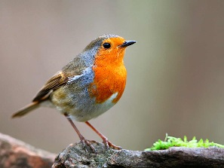 |  |  | 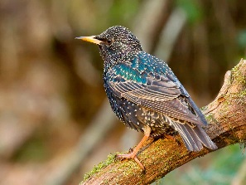
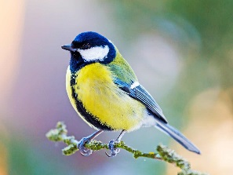 |  |  | 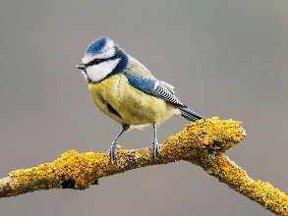
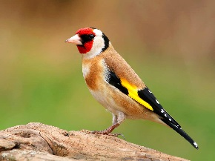 |  |  | 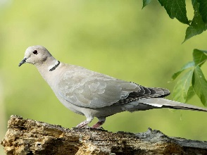
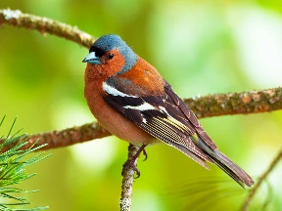 |  |  | 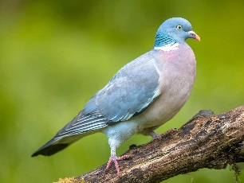
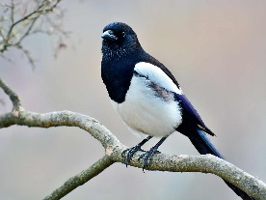 |  |  | 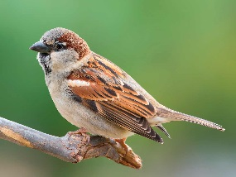
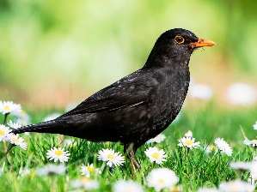 |  |  | 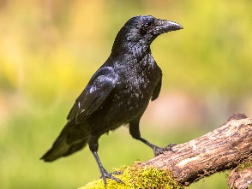

Key vocabulary
Goldfinch | Great tit | Magpie | Carrion crow
Chaffinch | House sparrow | Blackbird | Blue tit
Robin | Collared dove | Starling | Wood pigeon

