Mathematics - division
This week we have been learning about division using cubes.  We have learnt that each group must be equal.  This picture shows the calculation  18 ÷ 6 = 3 still being worked out. | 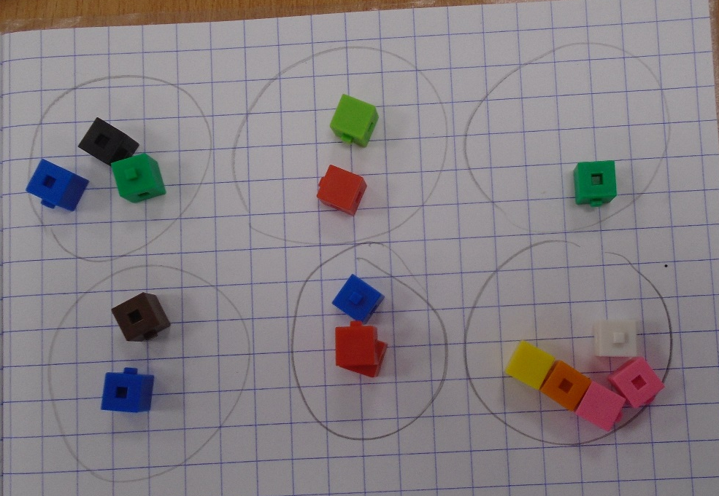
Can you check what is wrong with the cubes for this number sentence?  12 ÷ 2 = 6 | 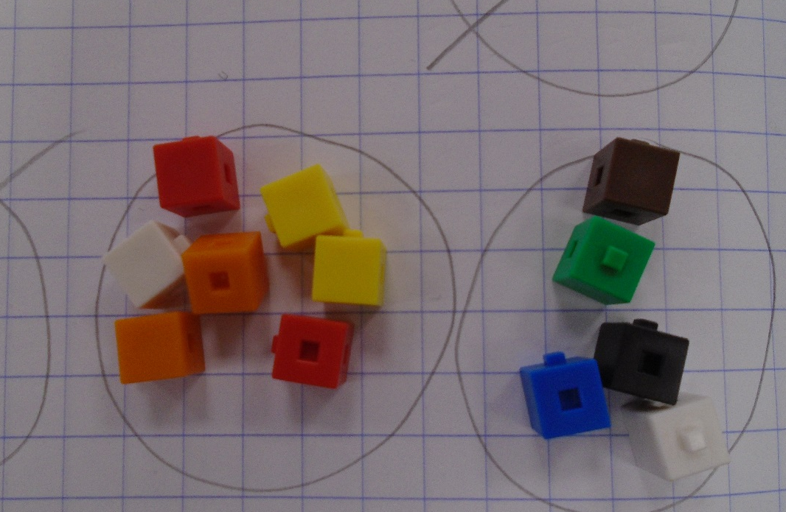
This book shows the correct number sentence  16 ÷ 4 = 4  And the pictorial representation for  15 ÷ 3 = 5 | 

