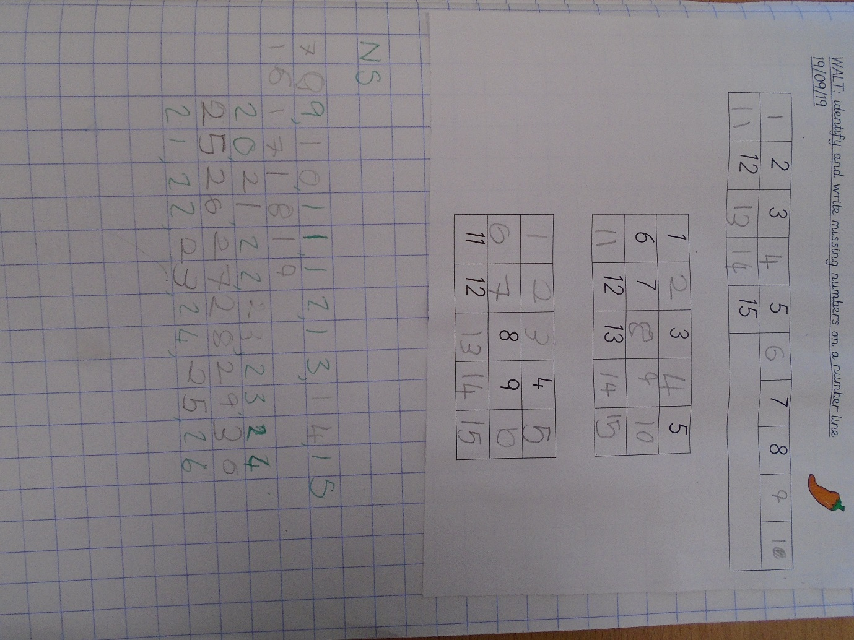
This week we have been focusing on place value, using deines. As a year group we have ordering and identifying the missing number. We have also been writing one digit in one square in our books to practise our number formation.

