Distance | Monday | Tuesday | Wednesday | Thursday | Friday | Saturday | Sunday
-Number of steps
-Distance you walked Km or Mile

Total
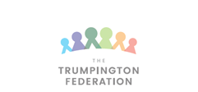
Mrs. Lewis’s Walking Challenge

Name:_____________________________________
Week beginning:__29th July 2020______________________________

Total steps/distance I have walked this week ______________________

Mindfulness Walking ‘Bring awareness to your body and surroundings’
*Notice how your body feels as you walk *Breathe deep *Be in the moment *Take in the world around you

