Name:
WALT (we are learning to): construct names of minibeasts.
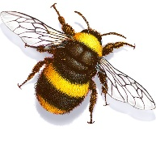____________________________________
 ___________________________________________

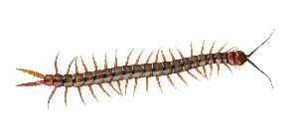___________________________________________
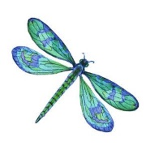 ______________________________________________
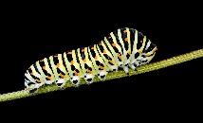 ___________________________________________
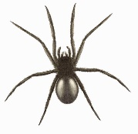_______________________________________________
Choose the two parts of each minibeast name that match, then write them next to the correct pictures.
cater bee
spi fly
butter pede
centi fly
dragon pillar
bumble der

