
Does your child have, or potentially have, an additional need or disability? Pinpoint (www.pinpoint-cambs.org.uk) have lots of information, advice and tips. For Cambridgeshire’s Local Offer go to www.cambridgeshire.gov.uk/residents/children-and-families/local-offer
Another Resource
The Easter HAF Programme will run from 30 March to 10 April 2026. Easter eligibility codes will be issued on 2 March 2026. The HAF team will assist with code and eligibility queries from this date. The Provider Directory will be available via a link on this page. Cambridgeshire Holiday Activities and Food (HAF) Programme | Cambridgeshire County Council Bookings are open now.
Information and Practical Tips to help support you and your child during the time of school transitions. www.place2be.org.uk/our-services/parents-and-carers/getting-ready-to-start-primary-school
How Parents Can Help With Secondary School Transition | YoungMinds

Parenting Top Tips
A visual timetable can help your child to understand the structure and activities of the day. Click the link to create your own visual timetable: Visual Timetable cards.pdf

Special time is a daily interaction with your child that is child led, it doesn’t need to be a long period of time, it can be just 10 mins. Playing with your child helps to build a warm relationship and a strong attachment between family members, it also helps to develop a child’s communication and social skills. Your child will learn to problem solve, test out their ideas and allows time to explore their imagination.

Praise, make sure you acknowledge and praise your child, catch them doing the right thing and praise them, using descriptive language such as “I liked that you shared your colouring pens”.

Emotion Coaching, emotion coaching supports emotional literacy, which means to recognise and understand feelings. You can help your child by doing activities together to practice develop their emotional literacy.

Feelings thermometer, this can help your child to identify how they are feeling.

Storytime reflection, after reading a book ask your child how they think the character felt and what would they do in that situation.
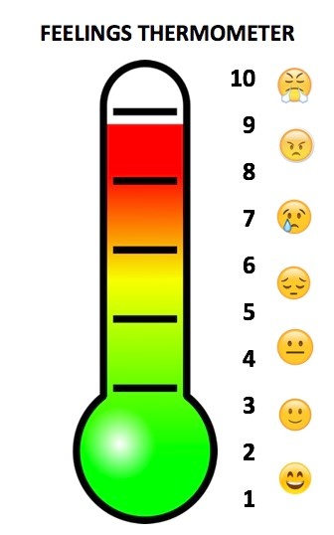

A Bit About Me
Hi, my name is Shelley Bari I’m your school’s link Education Inclusion Family Advisor (EIFA). As an EIFA I offer advice and strategies to parents and carers with a Primary School aged child that may be experiencing some challenges such as routines, sleep, sibling rivalry, challenging behaviour, worries or self-esteem. If you’d like a chance to chat about any of these topics, just contact me on the details below.

Contact me directly on ____________ or  Shelley.Bari@cambridgeshire.gov.uk

Activity Idea
If you are looking for a fun free way to get outside this Easter with your children, click the link below to download an Easter Nature Scavenger Hunt, this activity gets you all outdoors in the fresh air: Easter Nature Scavenger Hunt Color

Education Inclusion Family Advisor Newsletter
April 2026

