Tapestry for Parents and Relatives
Web Browser Version Guide

Note on Terminology: ‘Setting’ is a generic term for an educational establishment or education setting, such as a school, nursery, day-care or childminders. Unless a distinction is made it does not refer to computer settings or options.

Where to find Tapestry

To access the web browser version of Tapestry go to www.eylj.org or follow this link if reading a digital version of this guide. You can also use a setting specific link that staff at your child’s setting may have given you. Tapestry does not have high system requirements, but please make sure you update your web browser to the latest version available for the best user experience.
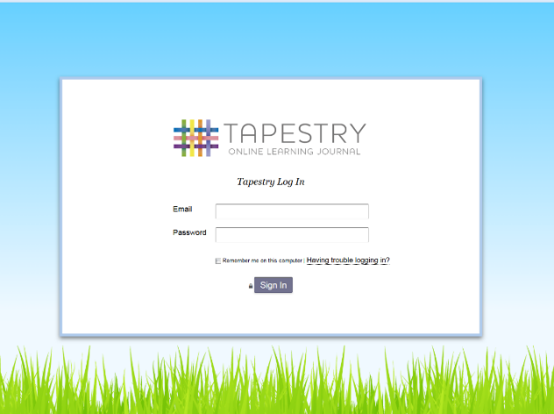

Login Information

In order to use Tapestry, your setting will have to create a user account for you on the system.
Tapestry support (the customer services team) are unable to create or modify relative accounts; if you have an issue with your Tapestry account please contact your setting. Tapestry support can only directly provide parents and relatives with basic advice on how to use the system.

Your Username: This will be the email address your setting used to register you on Tapestry, for example jparent@example.co.uk.
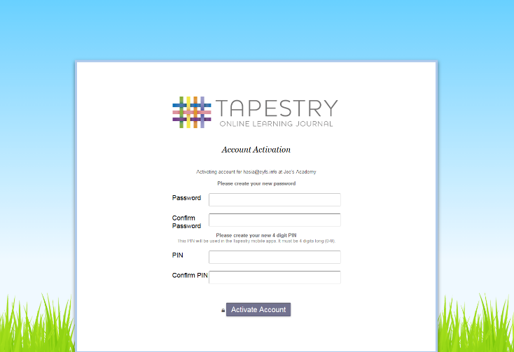
Your Password: You will get your password in one of several ways:
1) You will receive an email generated by your setting that contains a link you can follow to set up your own password and PIN number for Tapestry. This link will expire one week after it has been sent. If your link has expired or won’t work for another reason, please contact your setting manager for assistance.

2) Your password will already have been set by your setting. You will receive it in written form, or in an email sent by setting staff.
If the setting are printing this tutorial off for you, it may also be written here:

You can change both your email and password through the browser version of Tapestry whenever you like.
Tapestry Browser Version Interface: Observations Screen
Setting Specific Logo. This will vary depending on what your setting has chosen as its logo.
Search function
Add Observation button. Click on this to add a new observation
‘Obs’ Screen (current Tab)
List of Observations. Click the title or thumbnail image to view that observation. Scroll down on the page to see older observations
Page Filters. Use this to filter which observations you can see by various parameters

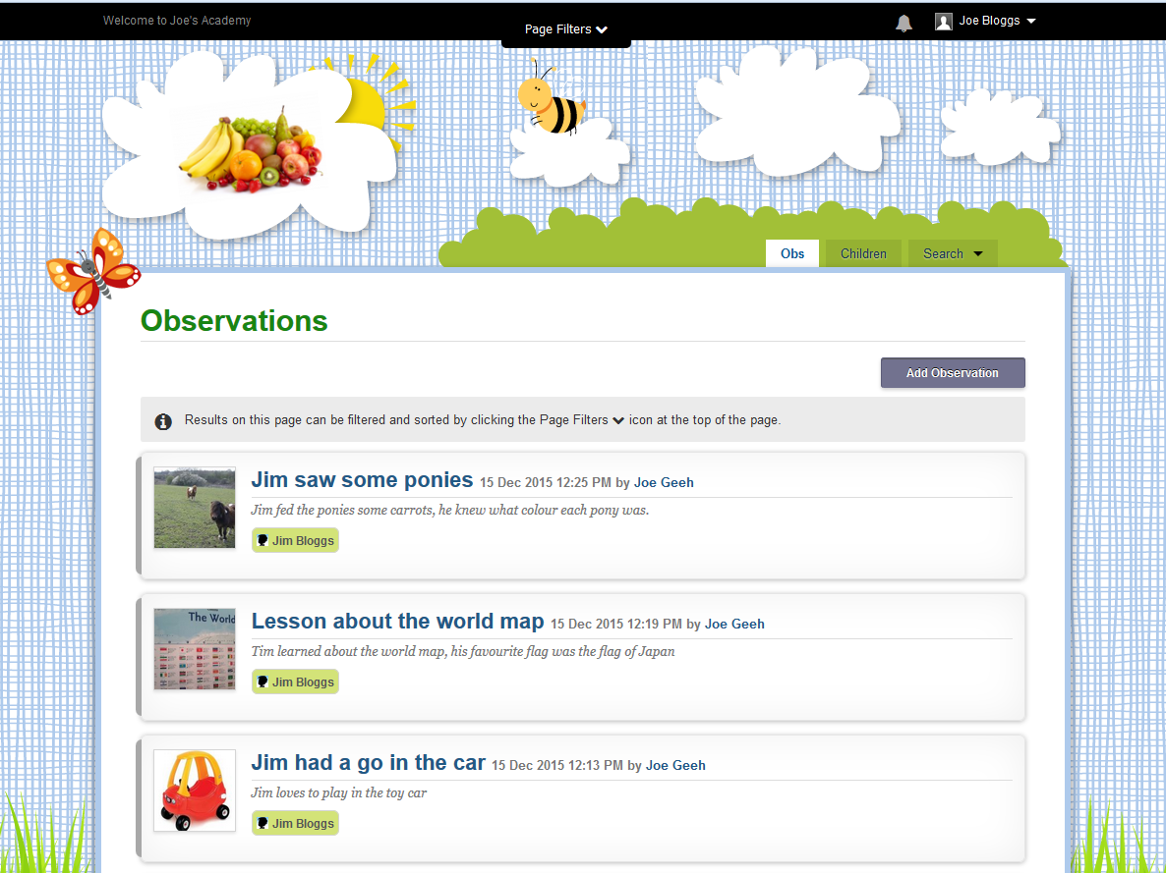
Children Tab. This displays all the children you are linked with on Tapestry

Edit Preferences. Clicking this opens the Preferences page. You can change your password and Tapestry email notifications settings.
Click Your Username at any time in Tapestry to open this drop down menu
Notification Alert Icon. Click this to view new Tapestry notifications

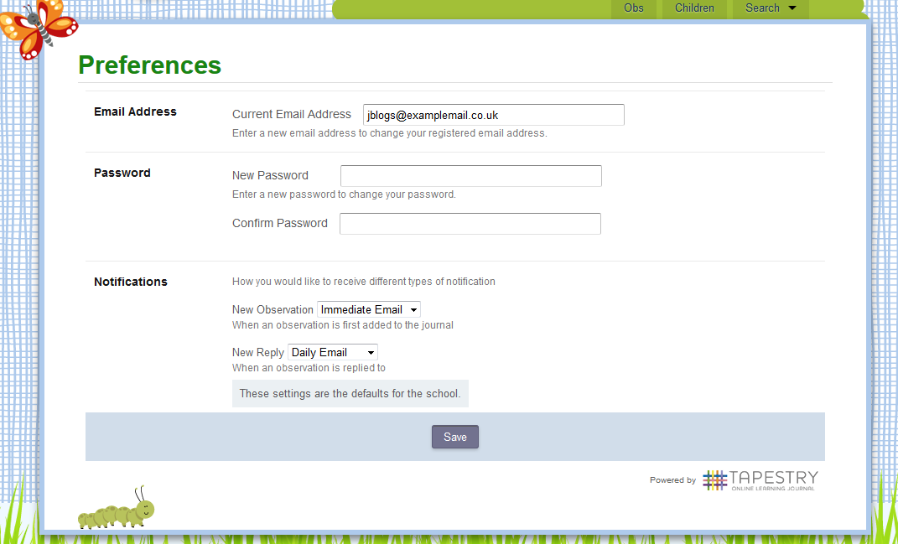

Help and Tutorials Link. Please see this for further assistance with Tapestry

Log Out Button
Viewing an Observation
To view an observation, click on the observation title or thumbnail image of an observation on the ‘Obs’ page
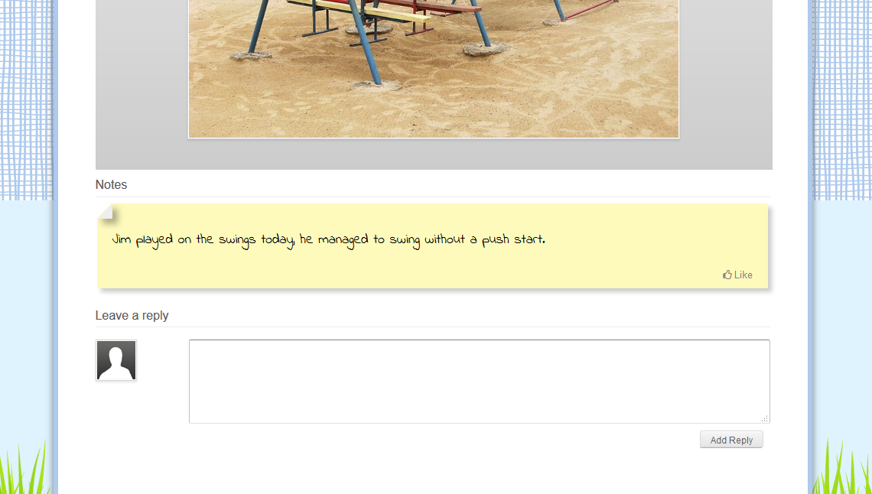
‘Like’ Button. Use this to show you like an observation
Observation Image. (Lower half)
Observation Notes

User Image. (Default)
Reply Section. Children’s relatives and setting staff can use the reply feature to discuss the observation or a related topic

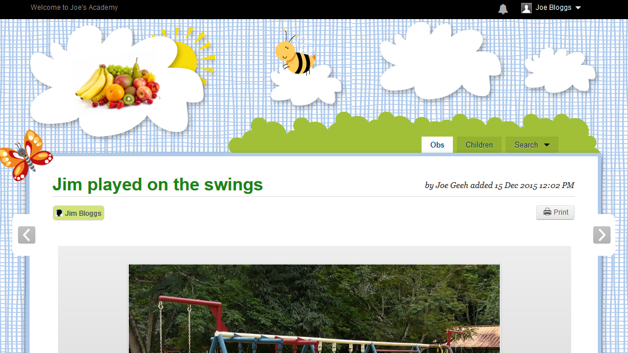
View Printer Friendly Page. This does not actually print the page, you need to use ctrl+p to do that, or the default for your web browser

Use these arrows to see the next or previous observation

Observation Image. (Top half)
Adding an Observation
Press the ‘Add Observation’ button on the observations page to add a new observation yourself.
First select which child you want to make an observation for. You will only be able to select your own children who you have been linked with on this Tapestry account. If you have two children on your Tapestry account you can include them both in the observation
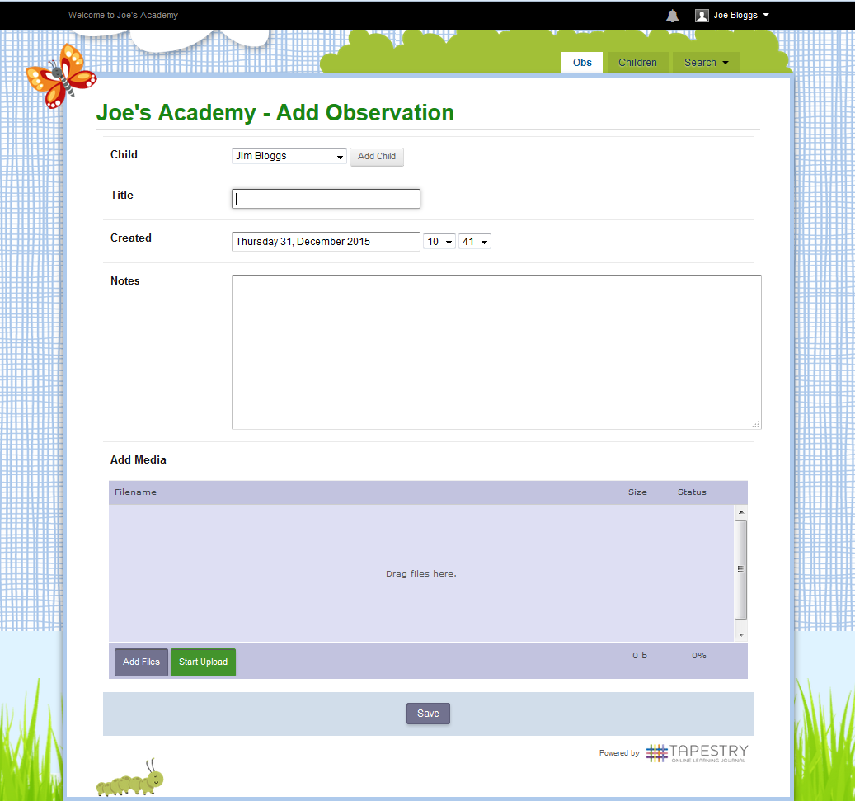
Once you are happy with your observation and all the media you want has been uploaded press ‘save’ to finish. Depending on the settings preferences you may have to wait for a member of staff to approve your observation before it is published to the Journal
You can include photos and videos with your observation. Click and drag the files into the blue area or press the ‘add files’ button. Once you have selected all the files press the ‘start upload’ button to upload them.
In the notes section, write as much as you like to describe what your child has done, and explain any pictures you have attached
Select the date. You can choose todays date or a date in the past if the observation actually happened on a different date
Give your observation an appropriate title

